Chapter 3: CNN and RNN using PyTorch

**Introduction**

Probability and random variable are integral part of computation in a graph computing platform like PyTorch. Understanding of the probability and associated concepts are essential. In this chapter we are going to cover probability distributions, and implementation using PyTorch and to interpret the results from the test. In probability and statistics, the random variable is also known as a stochastic variable whose outcome is dependent on a purely stochastic phenomenon, or random phenomenon. There are different types of probability distribution such as normal distribution, binomial distribution, multinomial distribution, Bernoulli distribution etc. each statistical distribution has its own properties.

## Problem:

How to set up loss function and optimize the loss function.

## Solution:

There are certain functions which are embedded in PyTorch and there are certain loss functions which the user has to create.

## How It works:

Let’s look at the following example.

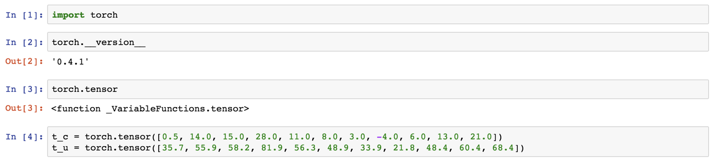

Sample model and loss function shown below.

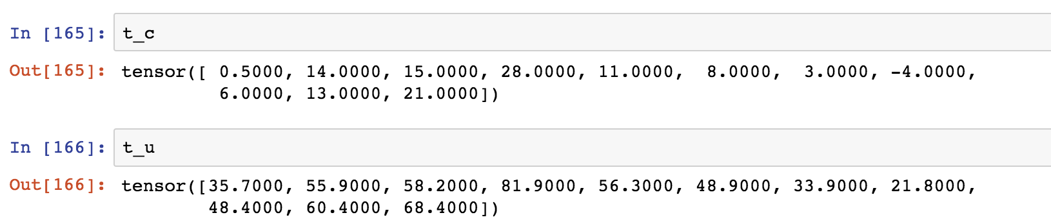

Let’s now define the model and the loss function.

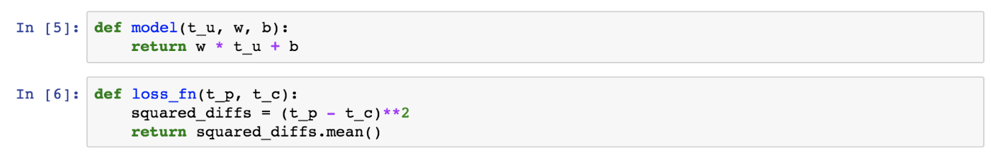

Creating the formula for tensor based computation.

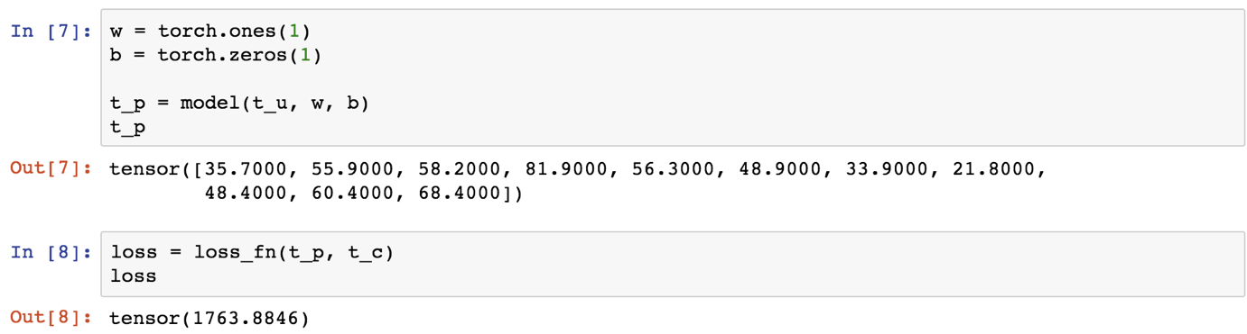

Loss estimation with respect to the weight has to be updated.

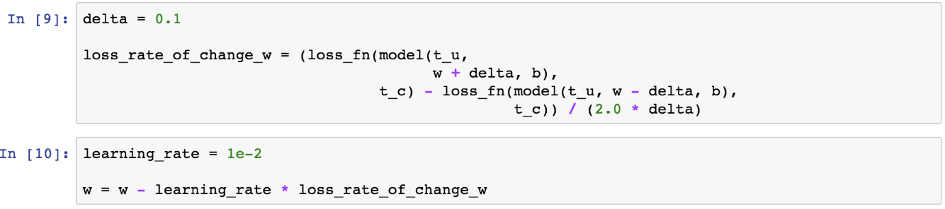

There are two parameters to update the rate of loss function.

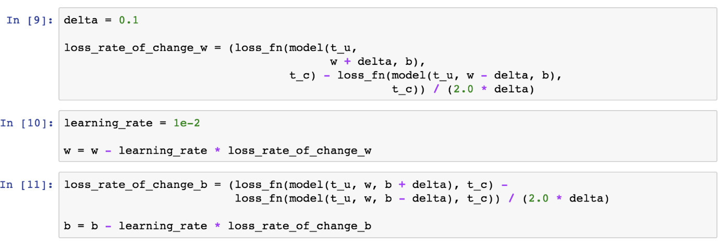

## Problem:

How to estimate the derivative of the loss function.

## Solution:

Using the following function.

## How It works:

Let’s look at the following example.

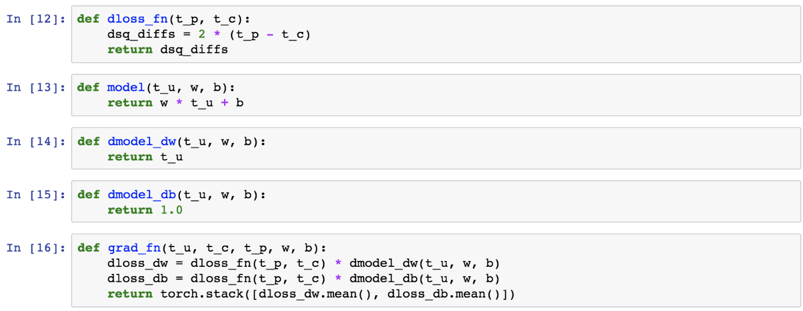

Parameter setting and the making the learning rate for model training.

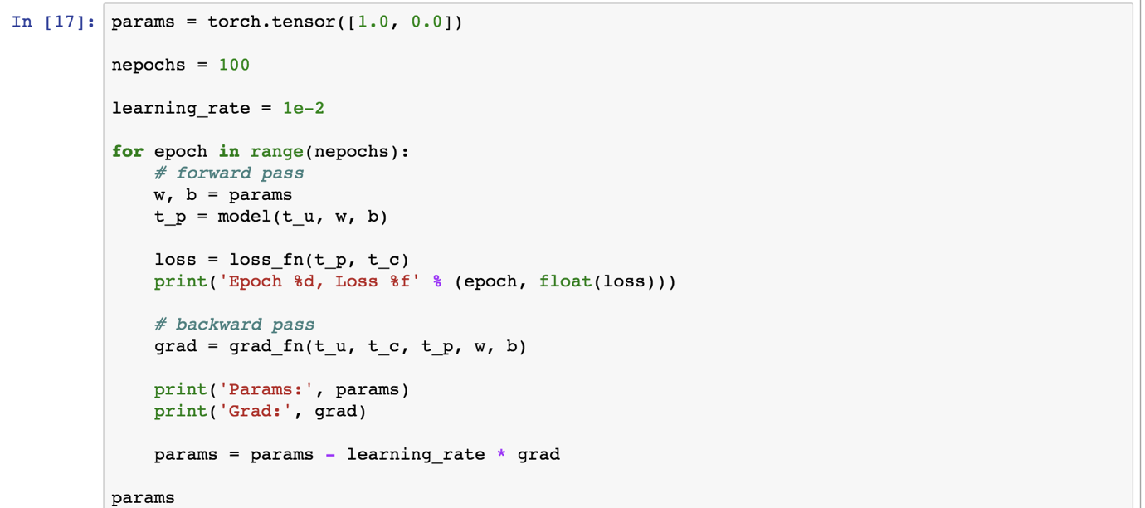

This is how the initial result would look like.

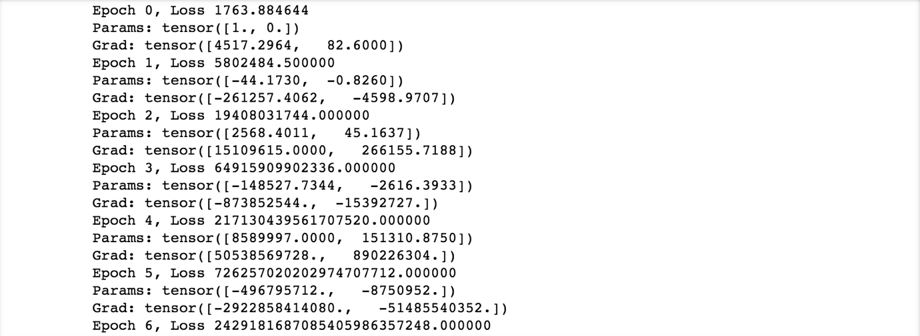

If we reduce the learning rate, then what happens is something that we have to see.

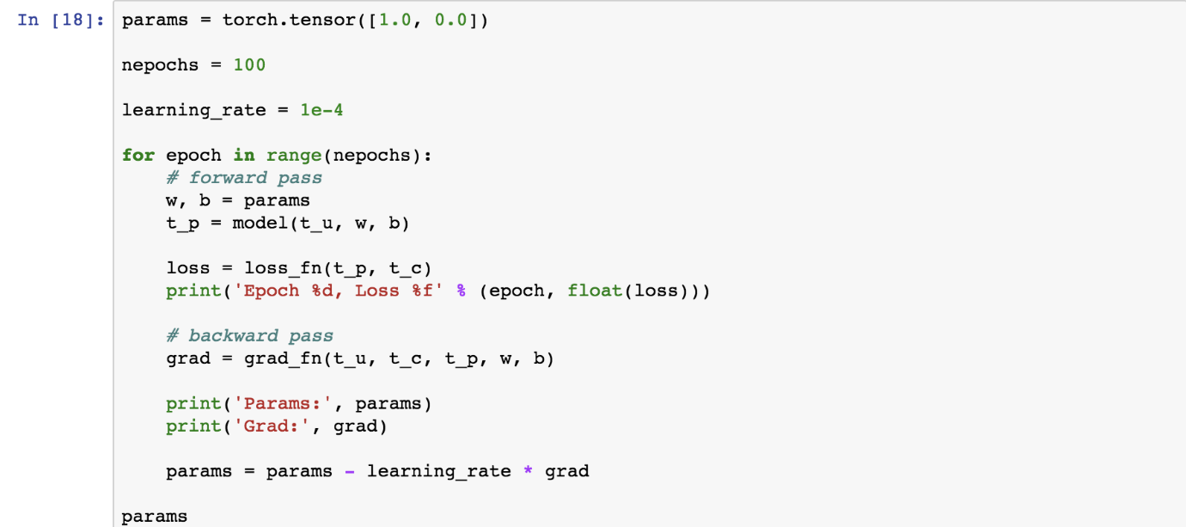

Initial results would look like as below.

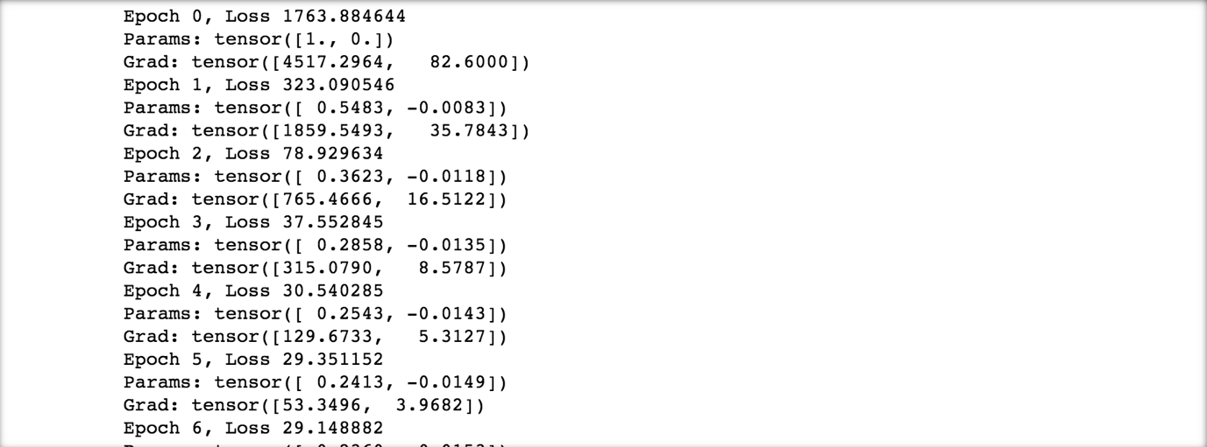

If we reduce the learning rate a bit then what happens.

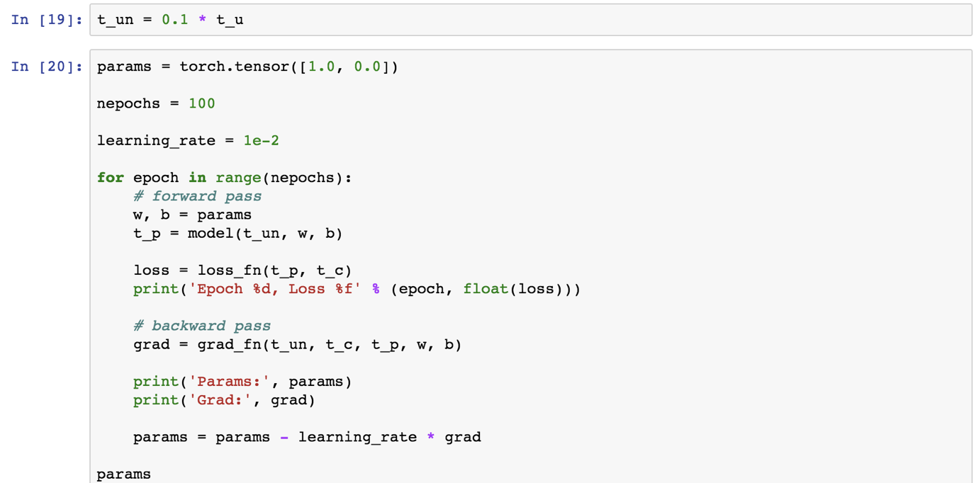

The following results we will observe.

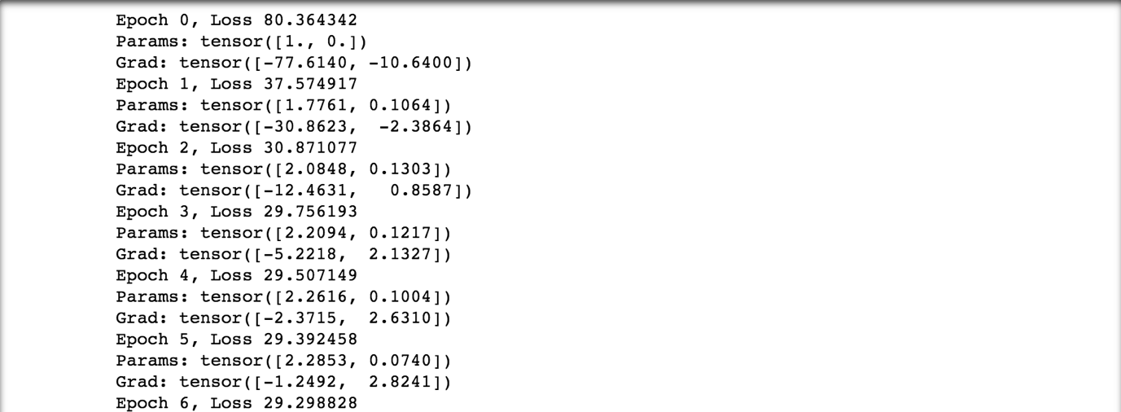

If we increase the number of epochs, then what happens to the loss function and parameter tensor also can be viewed as below.

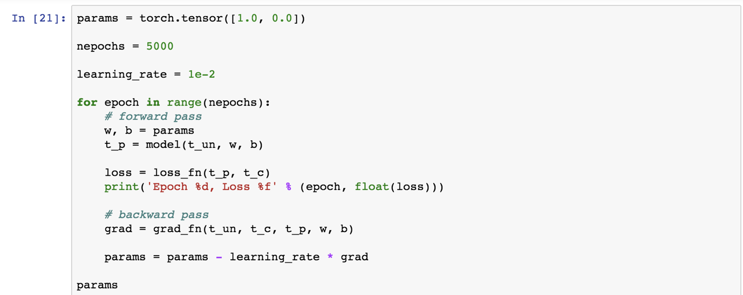

The following results we can observe.

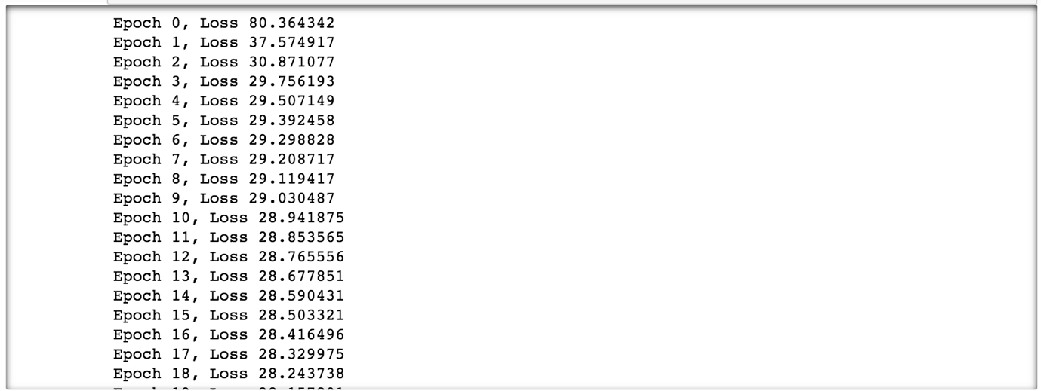

Let’s redefine the model and loss function and apply it to the same example.





Setting up the parameters.

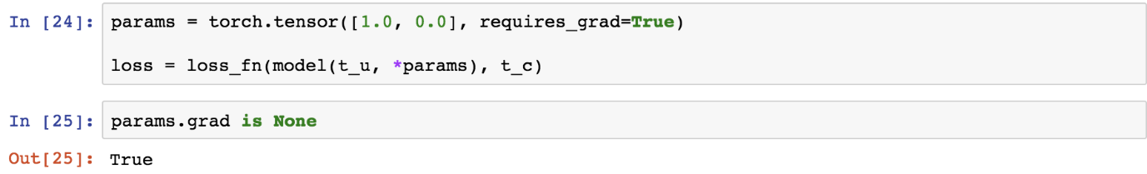

## Problem:

How to find out the gradients of the loss function and optimize the loss function.

## Solution:

There are certain functions which are embedded in PyTorch and there are certain loss functions which the user has to create.

## How It works:

Let’s look at the following example.

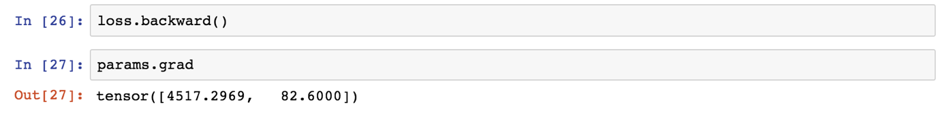

Resetting the parameter grid.

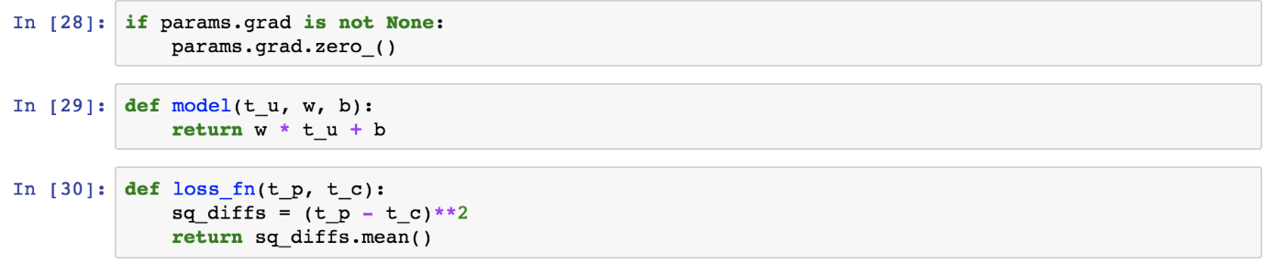

After redefining the model and the loss function, let’s retrain the model.

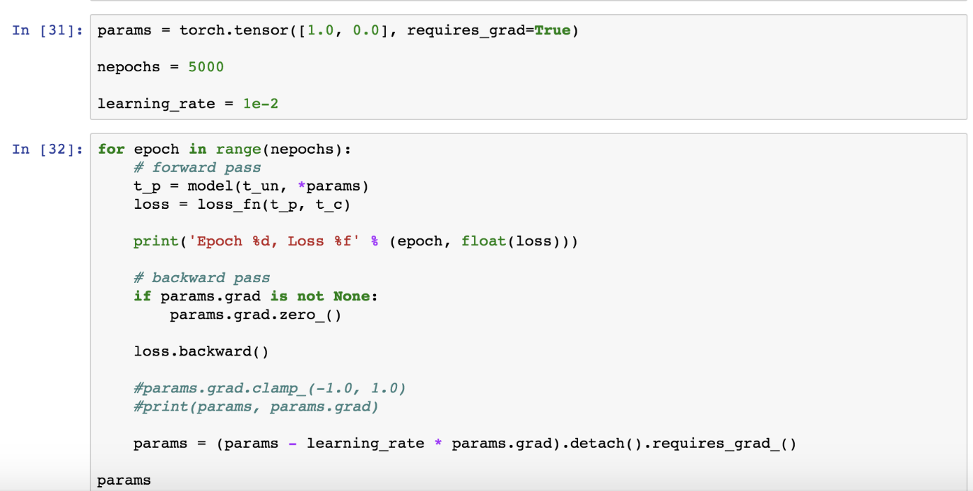

We have taken 5000 number of epochs, we train the parameters in backward propagation method and got the following result.

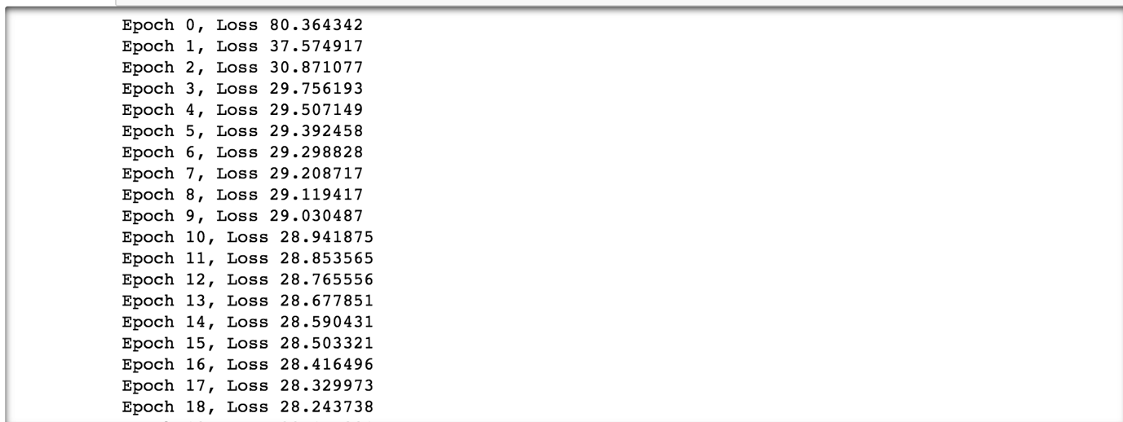

## Problem:

How to optimize the gradients with the above function.

## Solution:

There are certain functions which are embedded in PyTorch and there are certain optimization functions which the user has to create.

## How It works:

Let’s look at the following example.

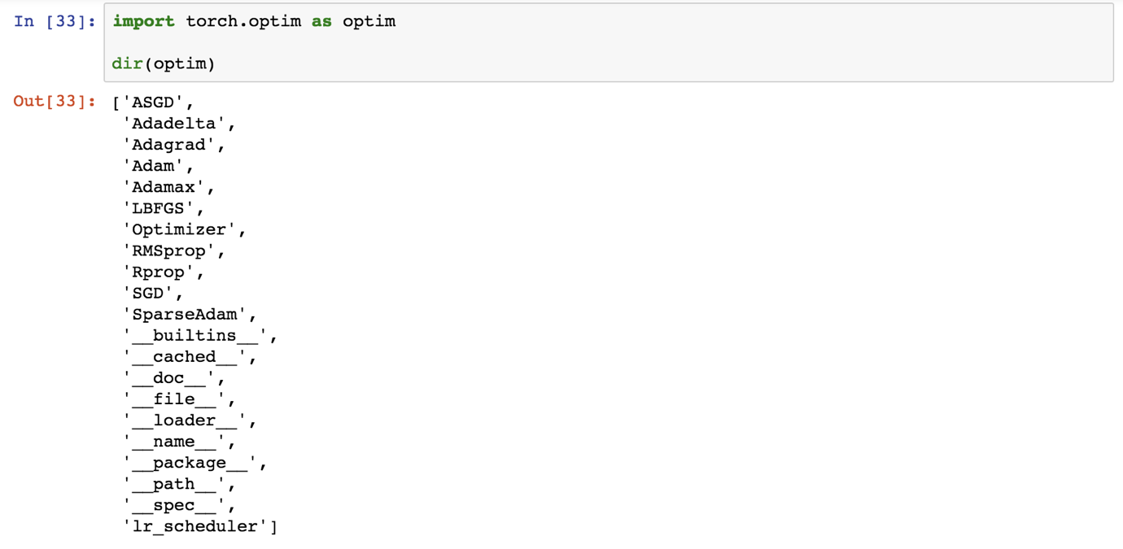

Each optimization method is unique in solving a problem. We will describe it later.

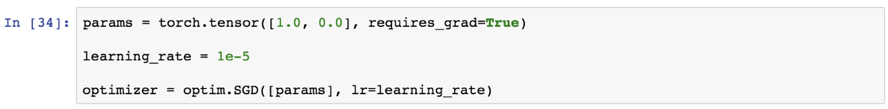

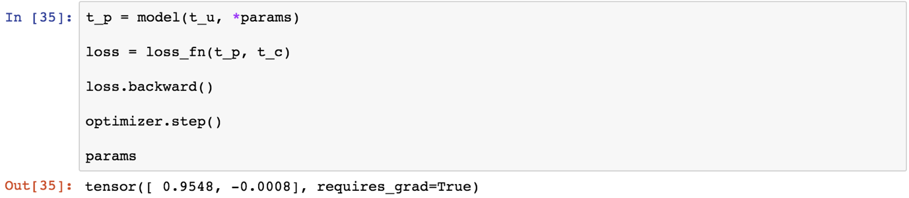

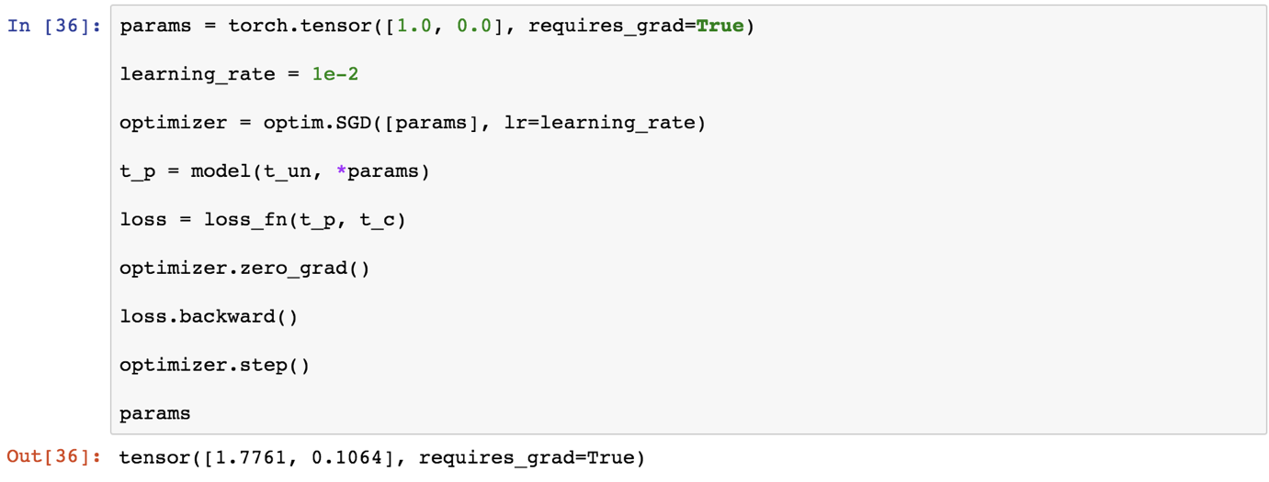

Now again let’s call the model and loss function out once again and apply along with the optimization function.

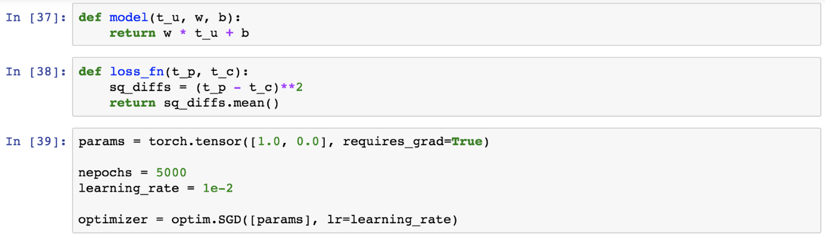

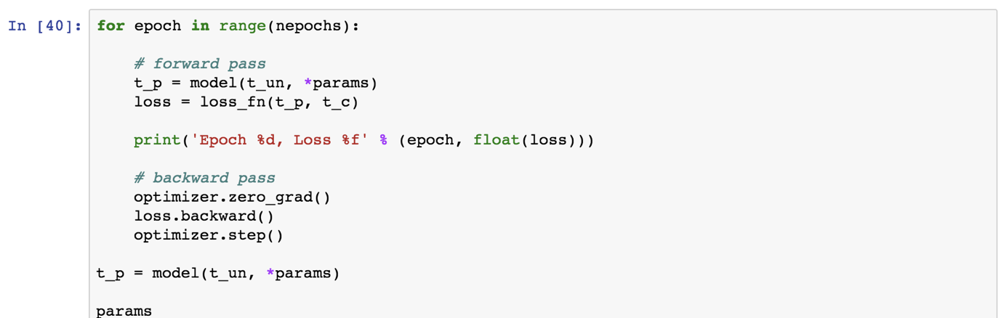

Let’s look at the drop in loss function.

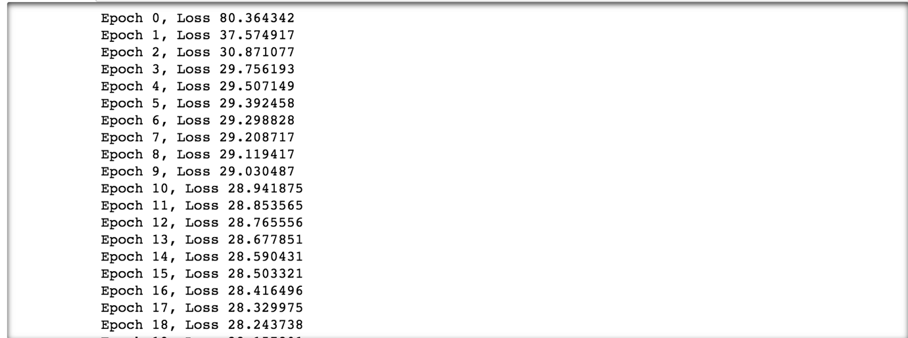

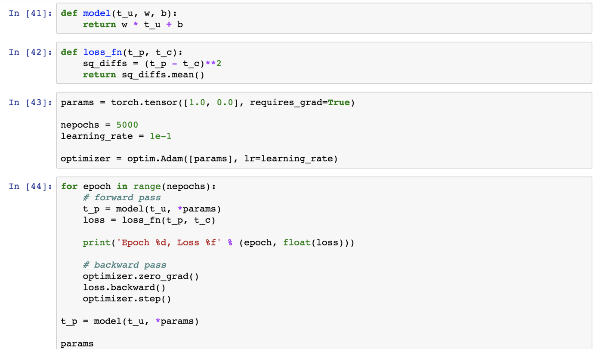

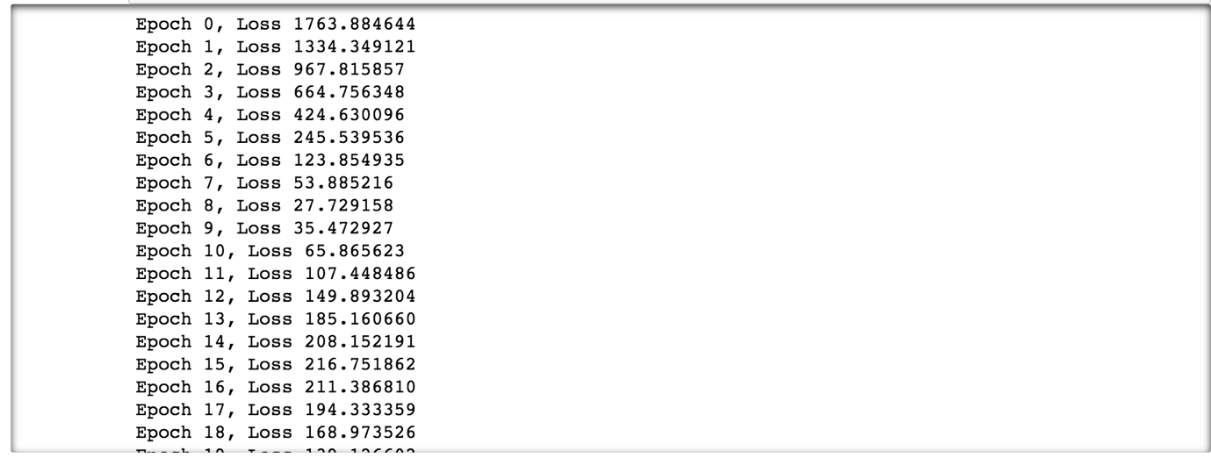

Let’s visualize the sample data in a graphical form.



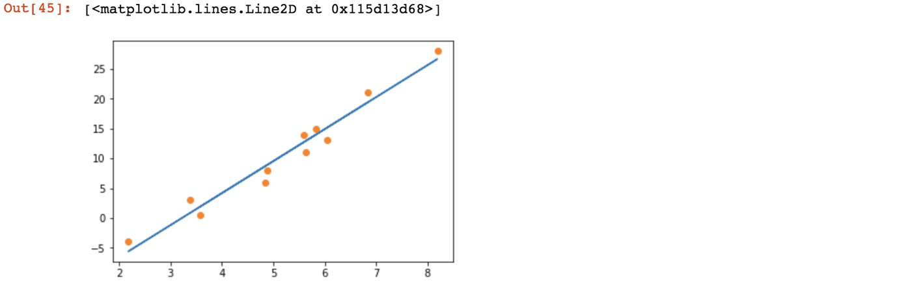

## Problem:

How to optimize the training set and test it out with validation set using the random samples.

## Solution:

There are certain functions which are embedded in PyTorch and there are certain loss functions which the user has to create.

## How It works:

Let’s look at the following example.

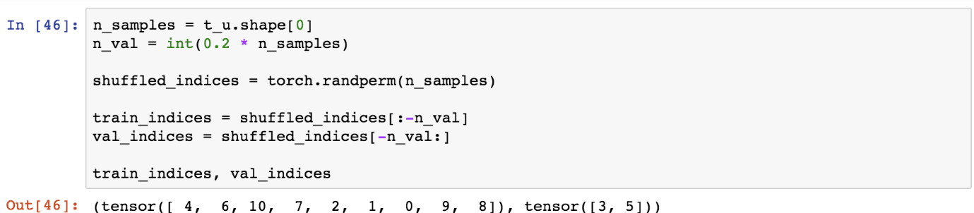

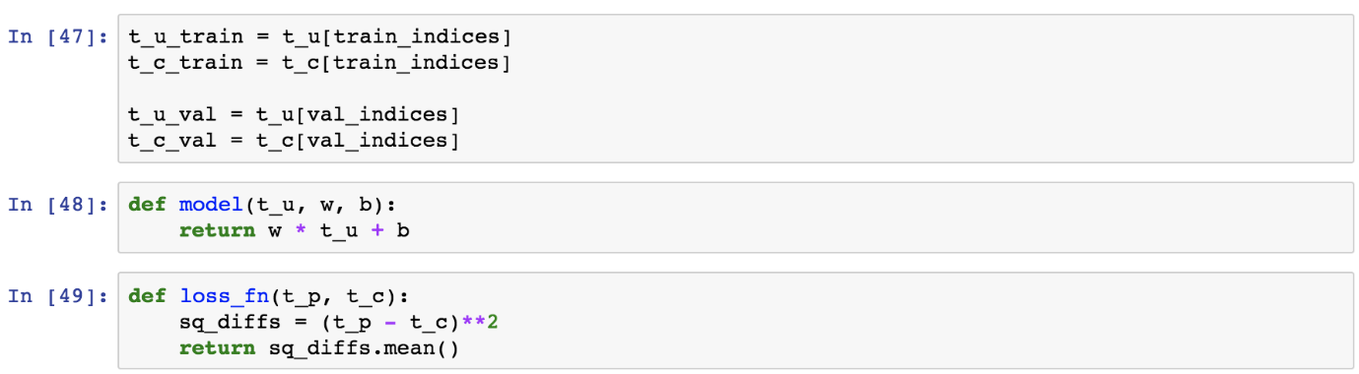

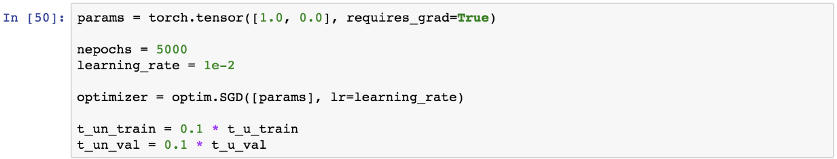

Now let’s run the train and validation process.

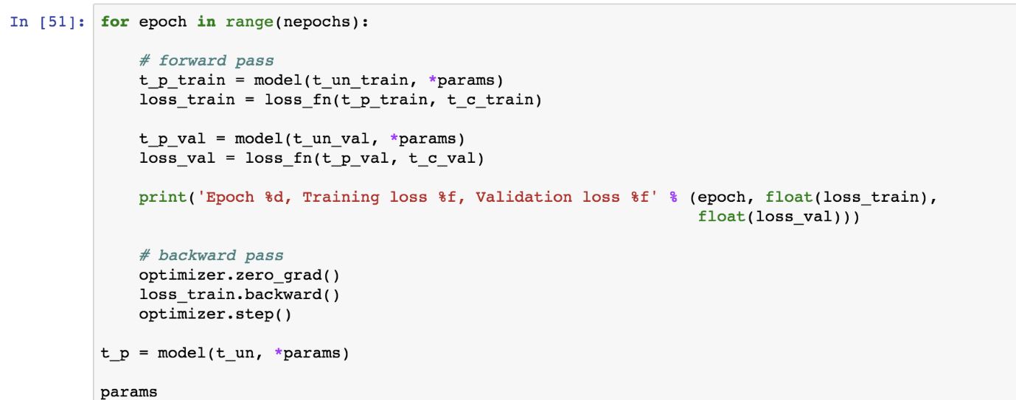

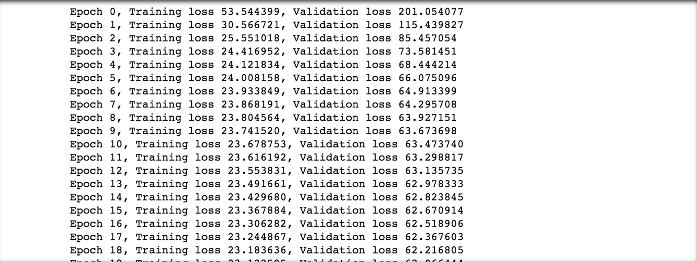

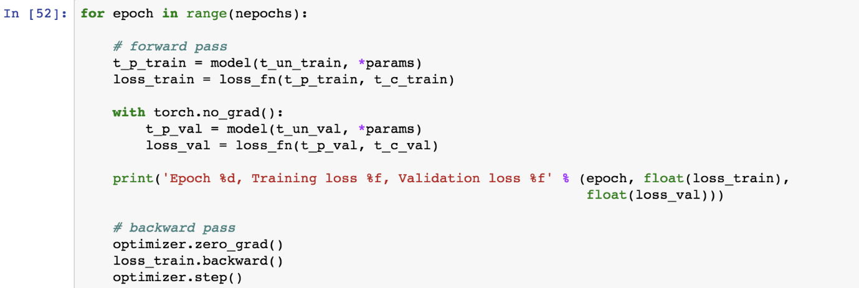

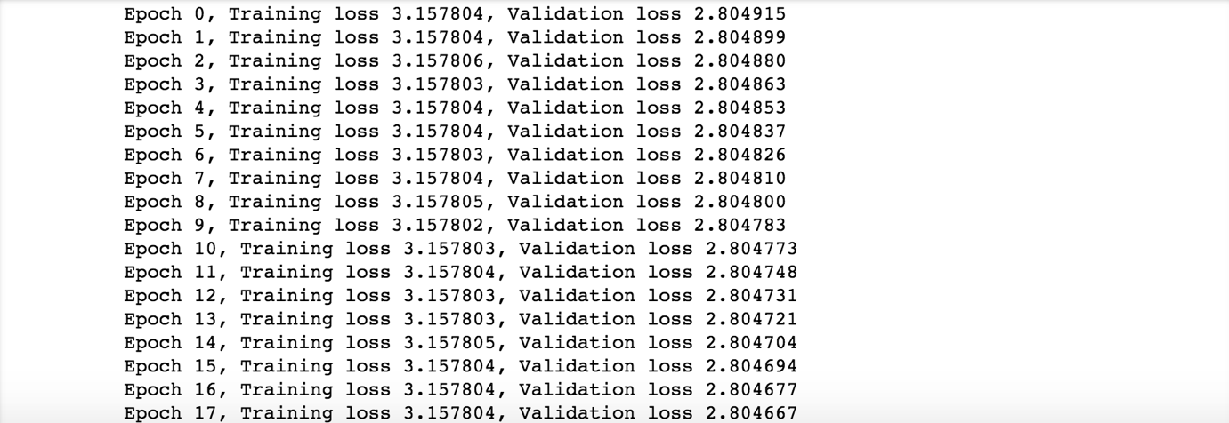

## Problem:

How to implement a convolutional neural network using PyTorch.

## Solution:

There are various built in data sets available on torch vision, we are considering the MNIST dataset and trying to build a CNN model.

## How It works:

Let’s look at the following example.

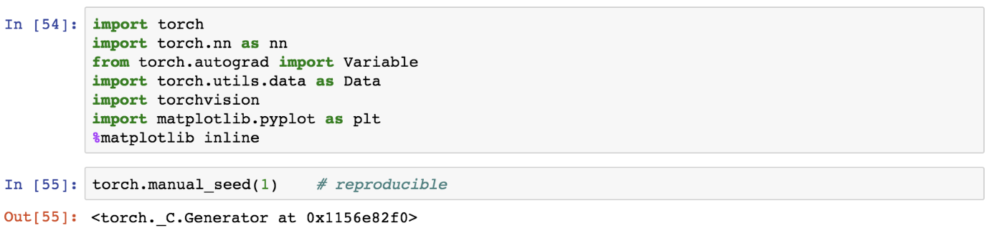

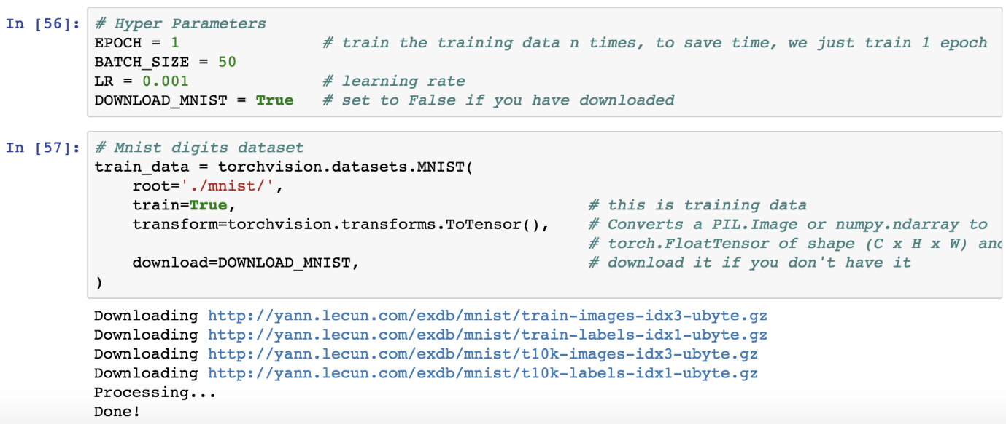

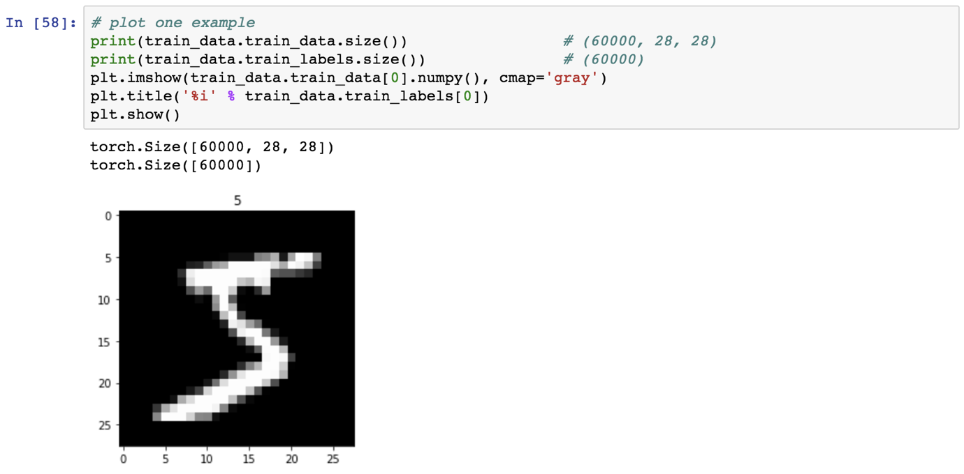

Let’s load the dataset using loader functionality.

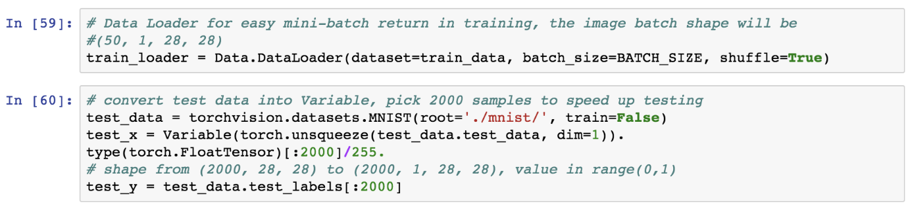

Setting up the CNN architecture.

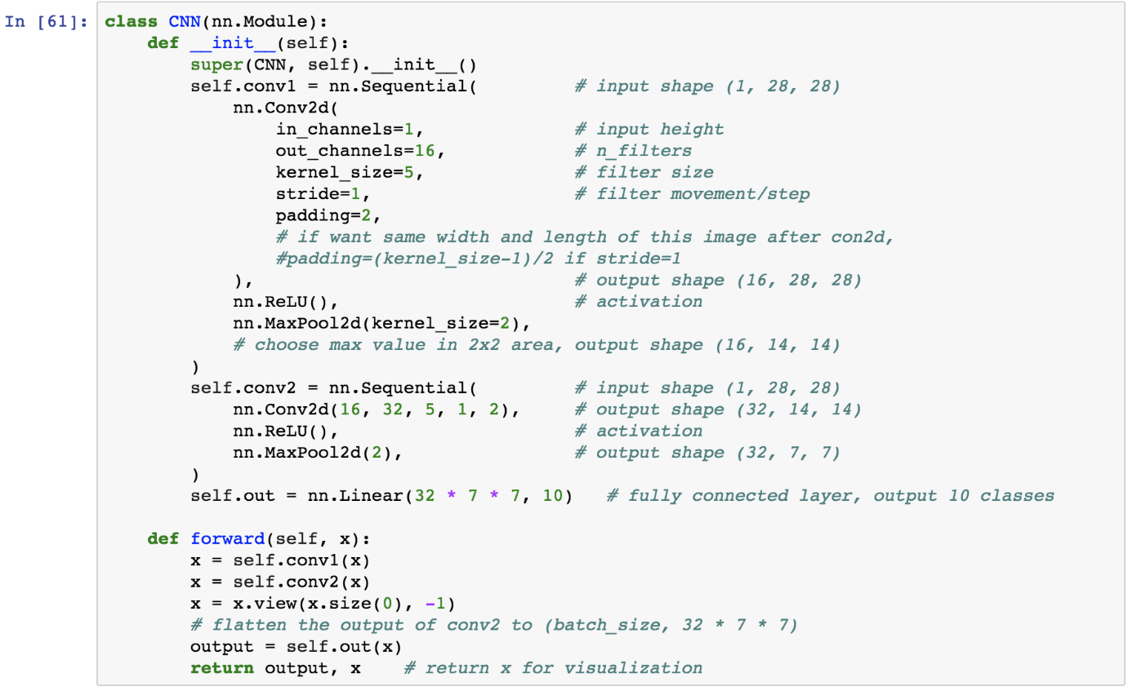

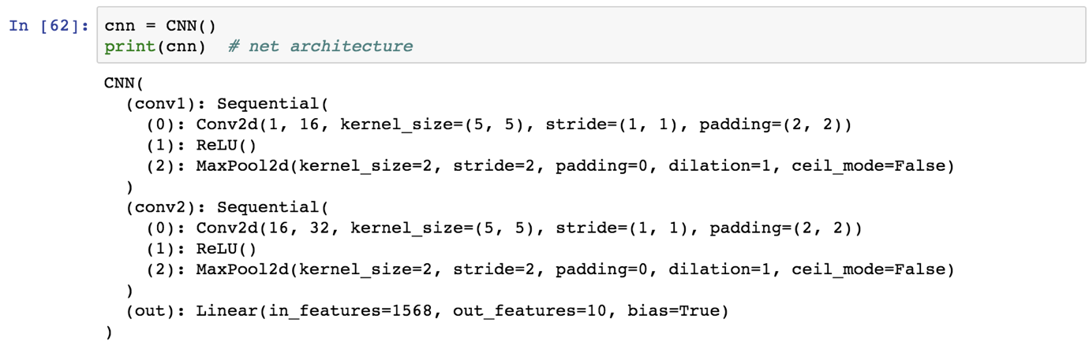



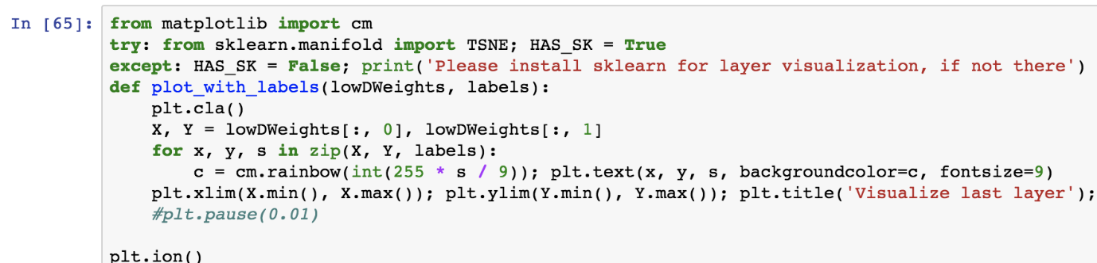

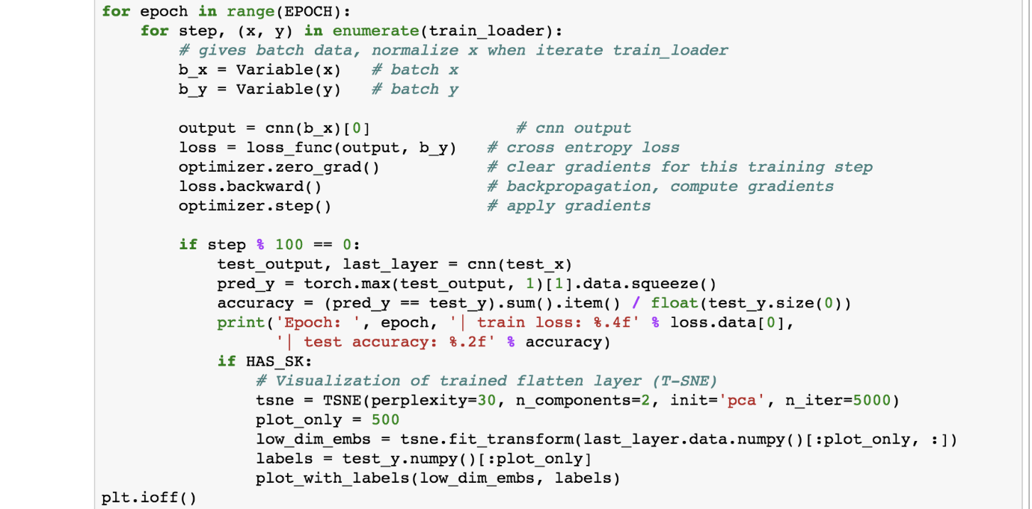

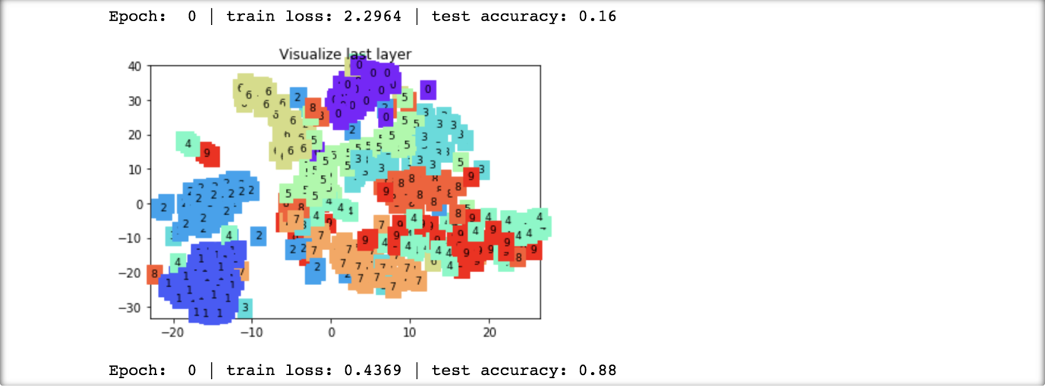

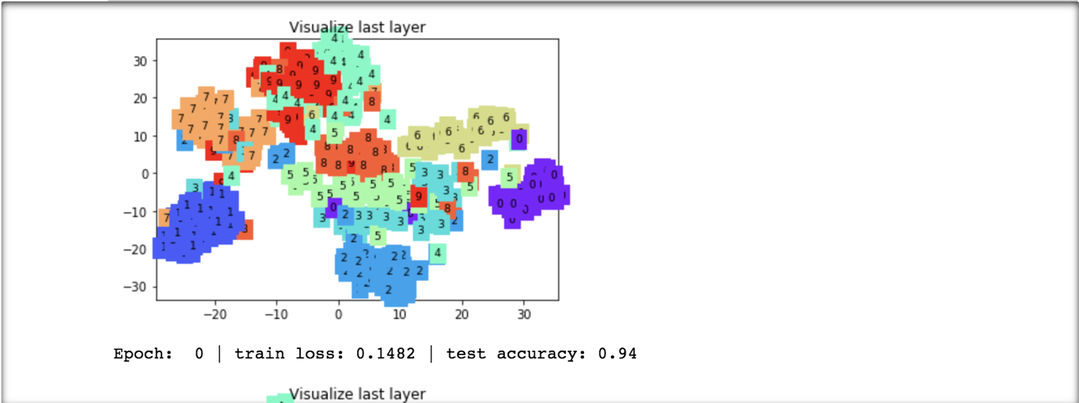

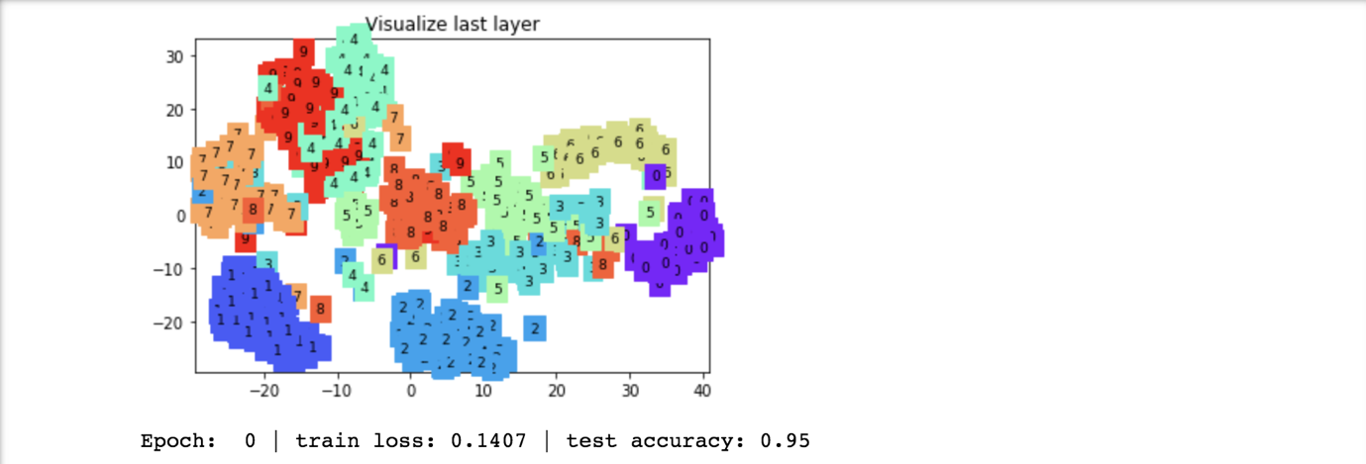

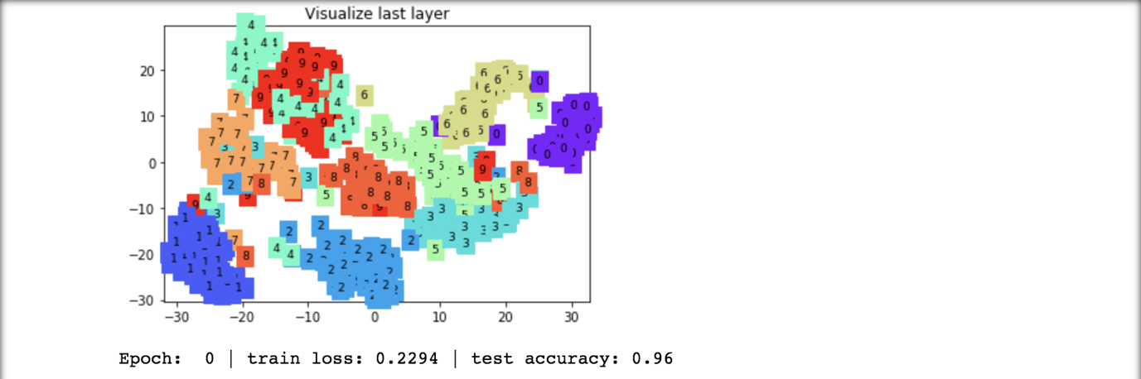

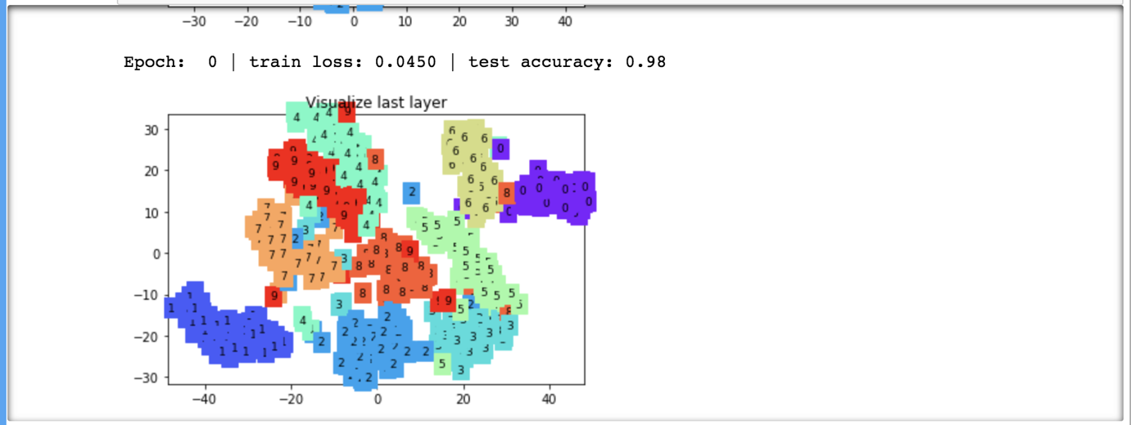

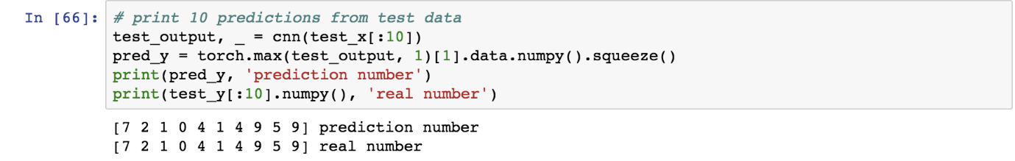

## Problem:

How to store and re-upload a model that has already been trained.

## Solution:

There are certain functions which are embedded in PyTorch and there are certain loss functions which the user has to create.

## How It works:

Let’s look at the following example.

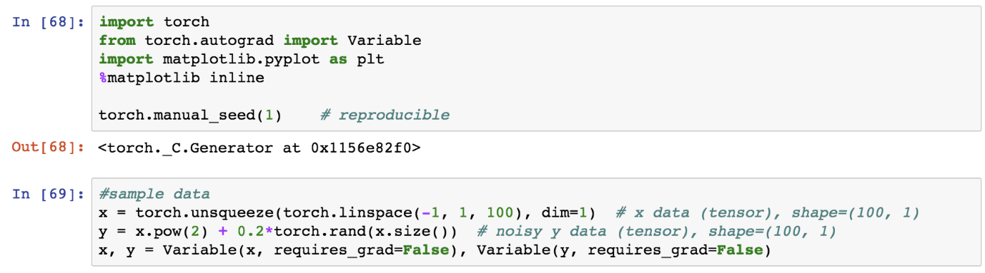

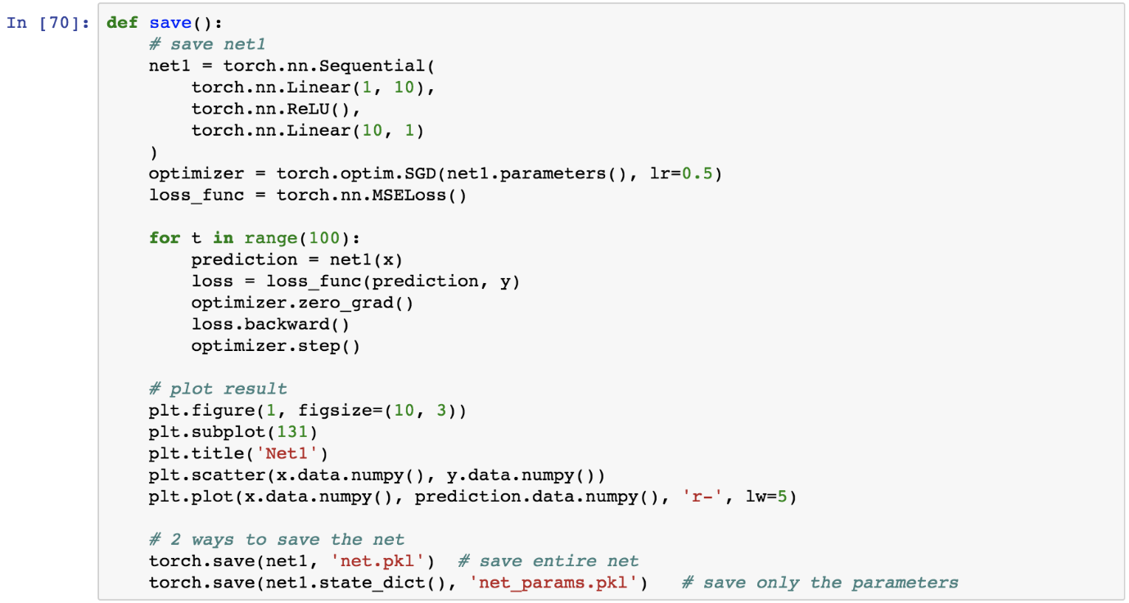

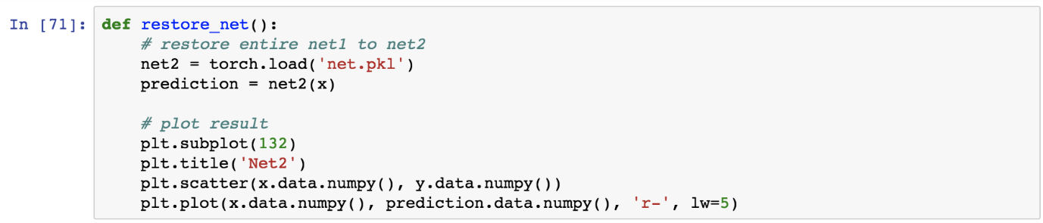

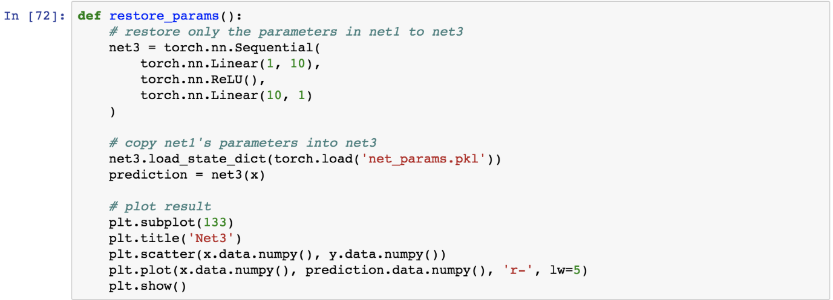

Saving the re-using the model.

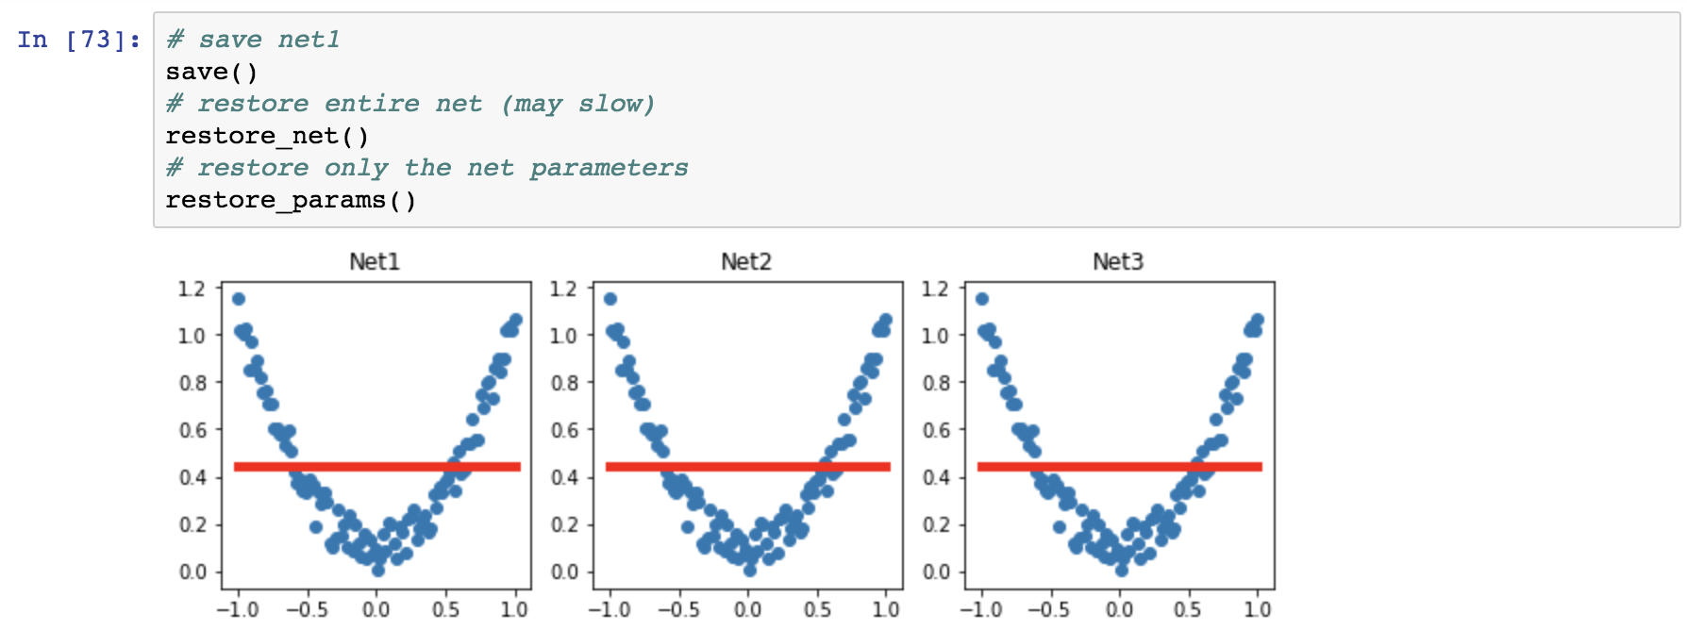

## Problem:

How to set up recurrent neural network.

## Solution:

There are certain functions which are embedded in PyTorch and there are certain loss functions which the user has to create.

## How It works:

Let’s look at the following example.

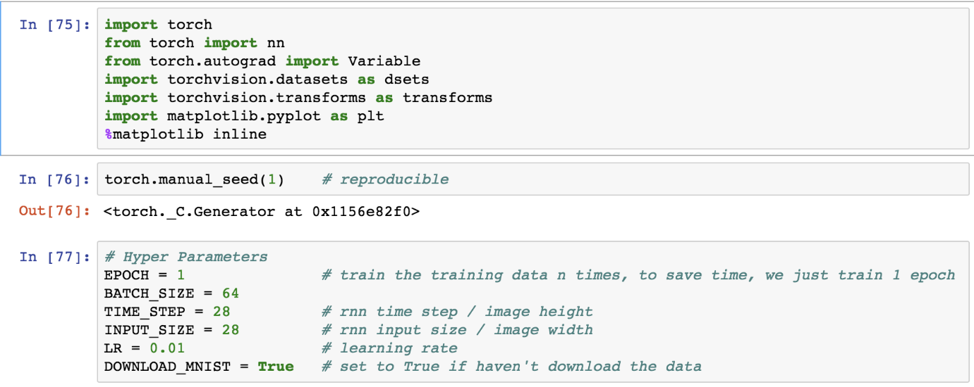

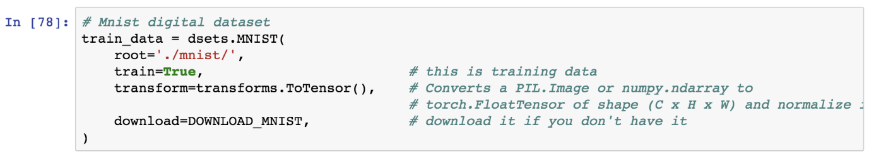

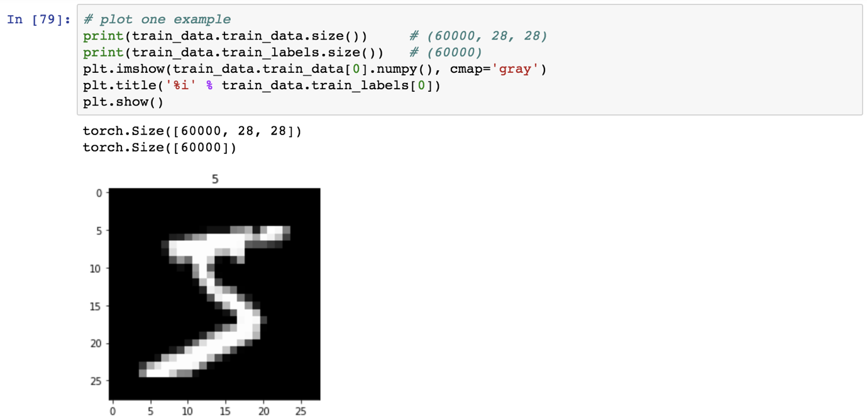

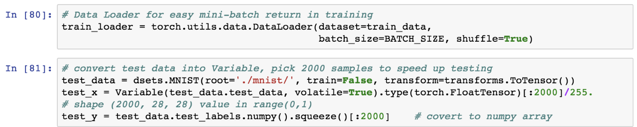

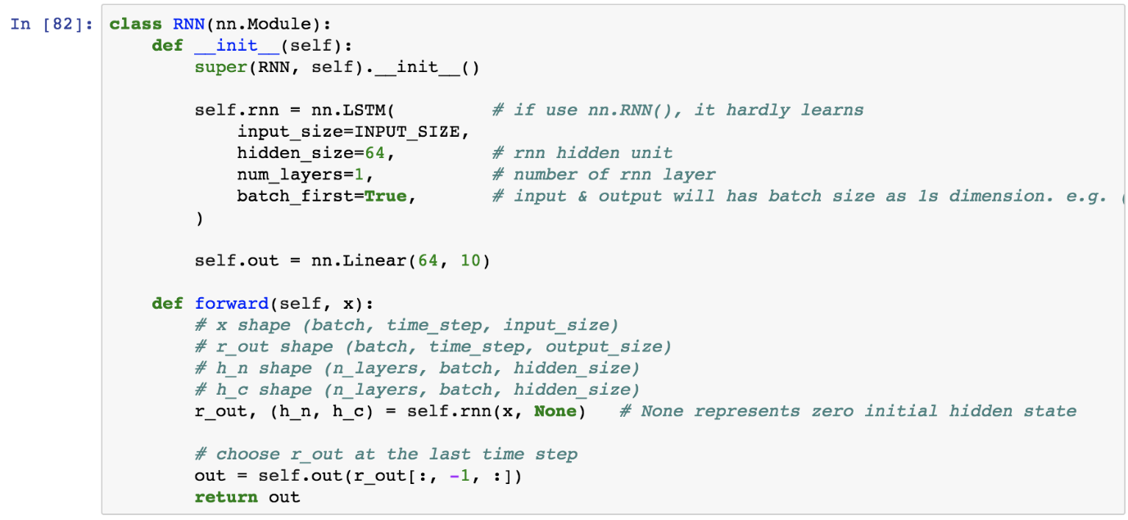

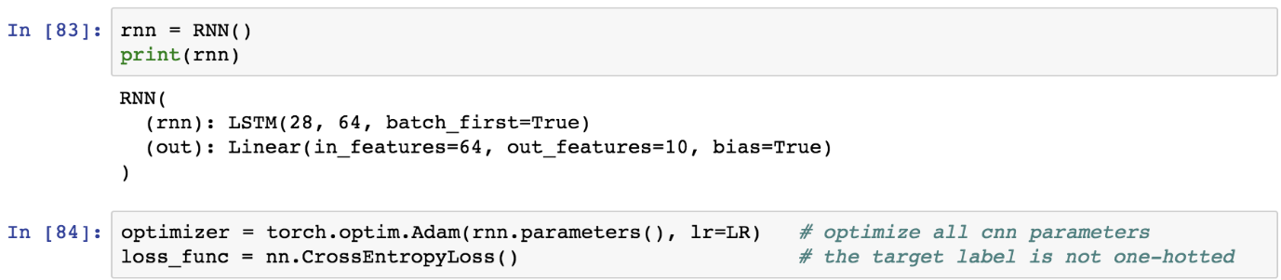

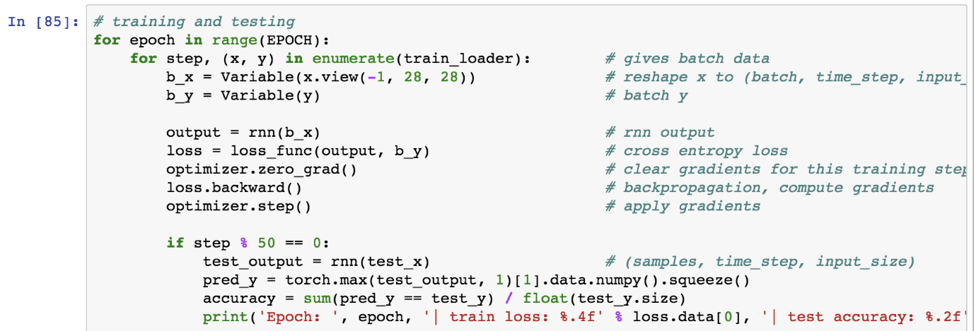

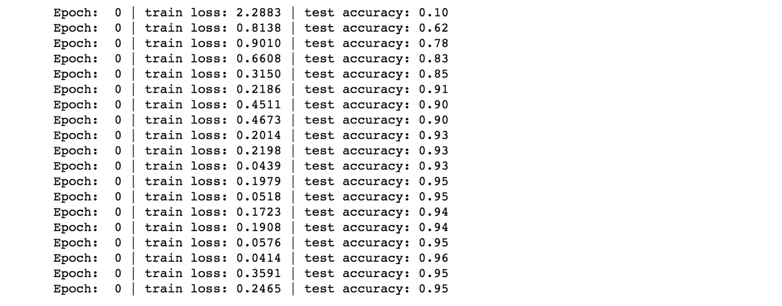

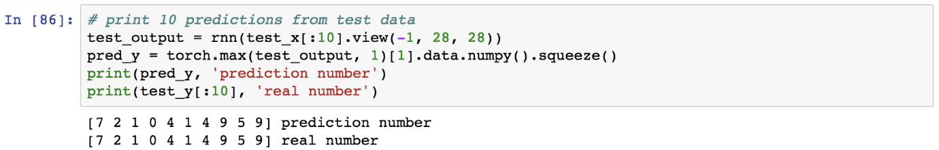

## Problem:

How to set up recurrent neural network for regression based problems.

## Solution:

There are certain functions which are embedded in PyTorch and there are certain loss functions which the user has to create.

## How It works:

Let’s look at the following example.

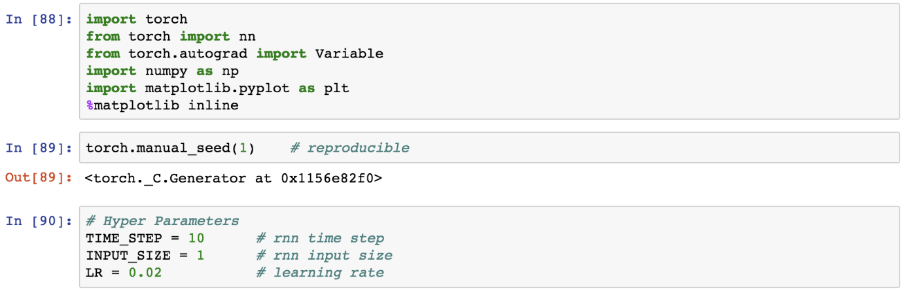

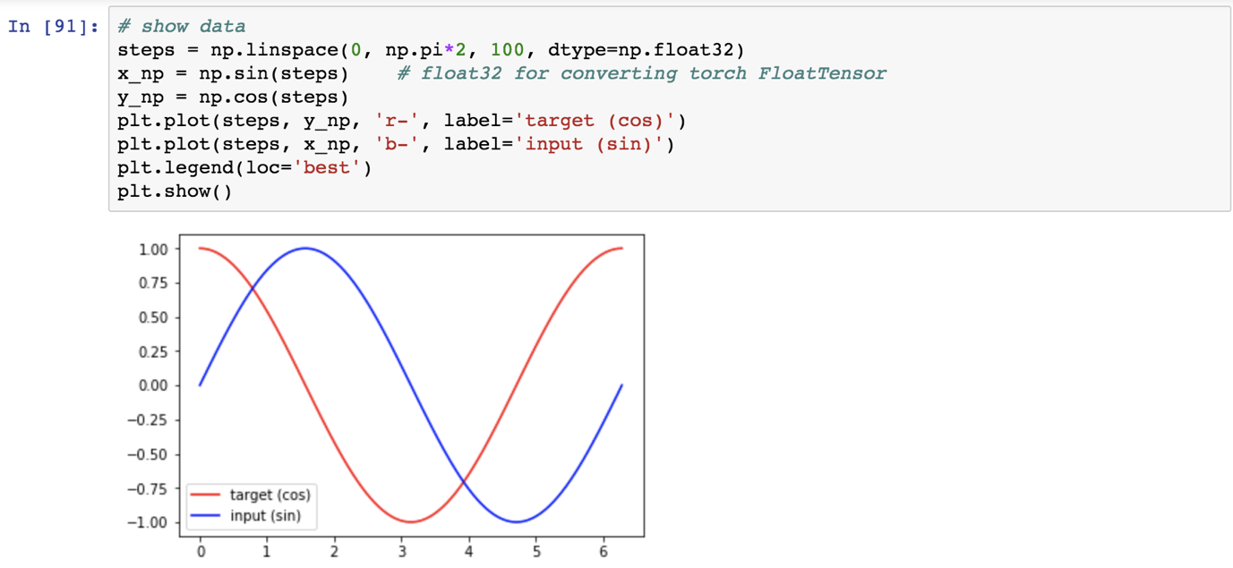

## Problem:

How to set up RNN module and call the RNN function using PyTorch.

## Solution:

There are certain functions which are embedded in PyTorch and there are certain loss functions which the user has to create.

## How It works:

Let’s look at the following example.

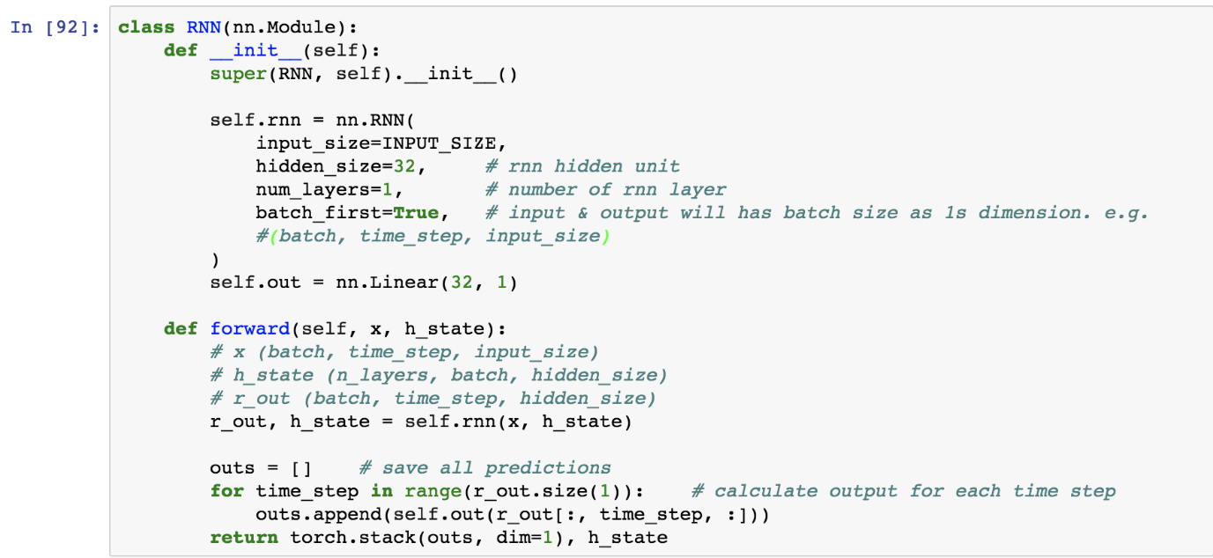

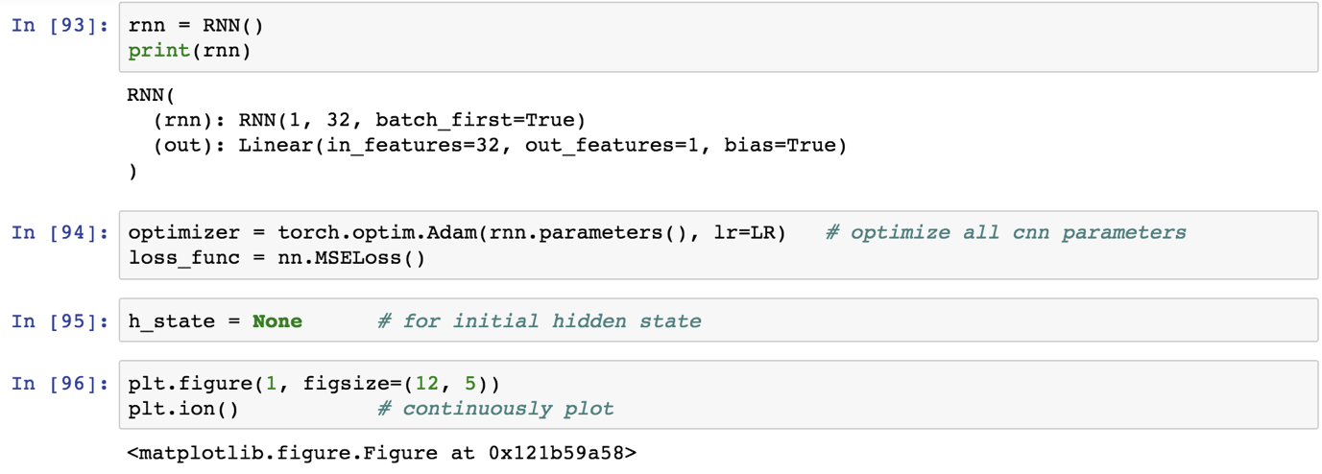

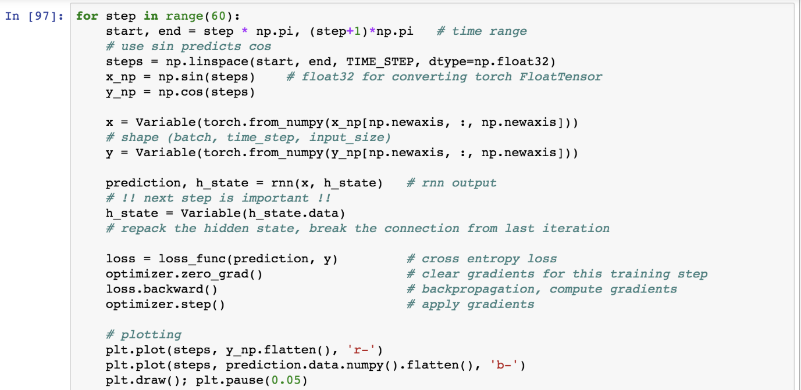

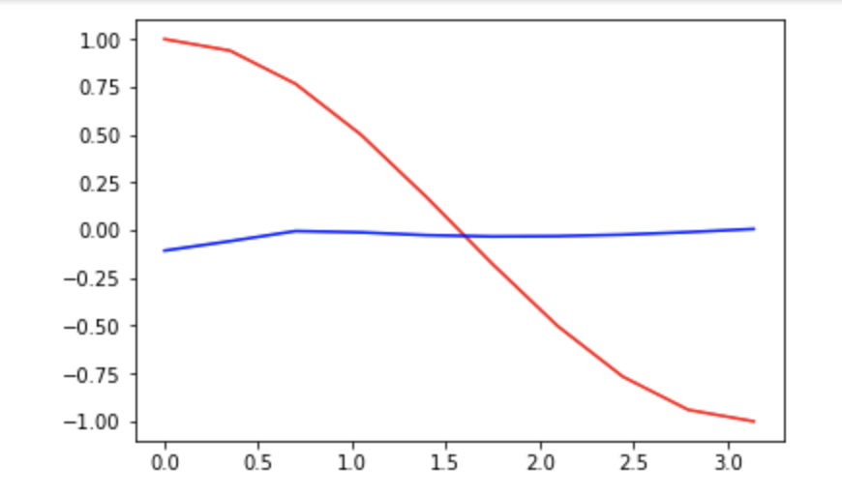

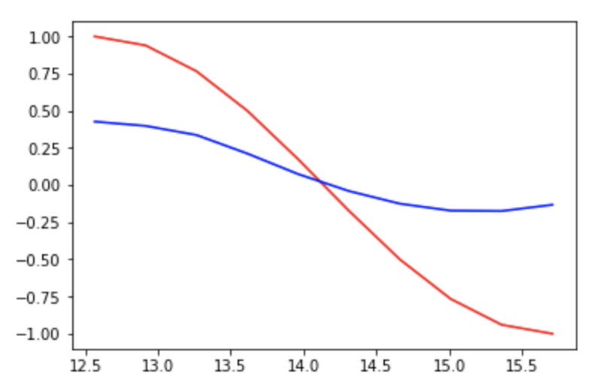

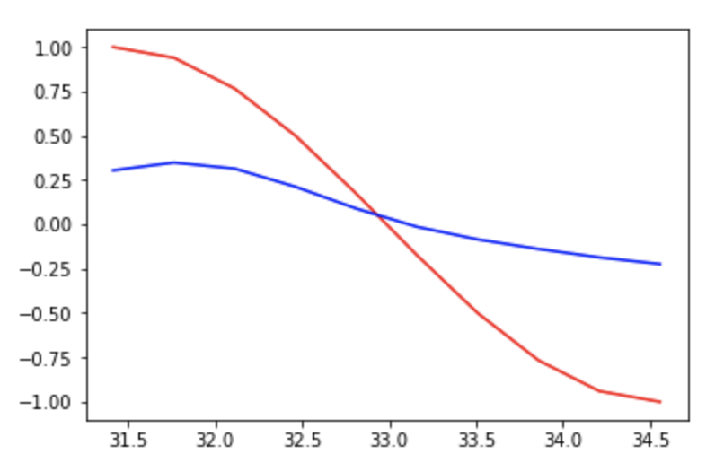

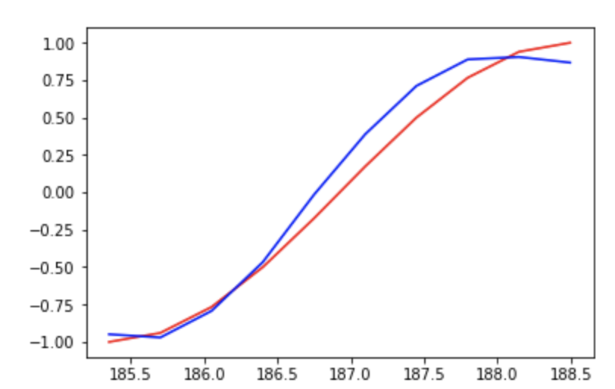

## Problem:

How to perform clustering using autoencoders function.

## Solution:

There are certain functions which are embedded in PyTorch and there are certain loss functions which the user has to create.

## How It works:

Let’s look at the following example.

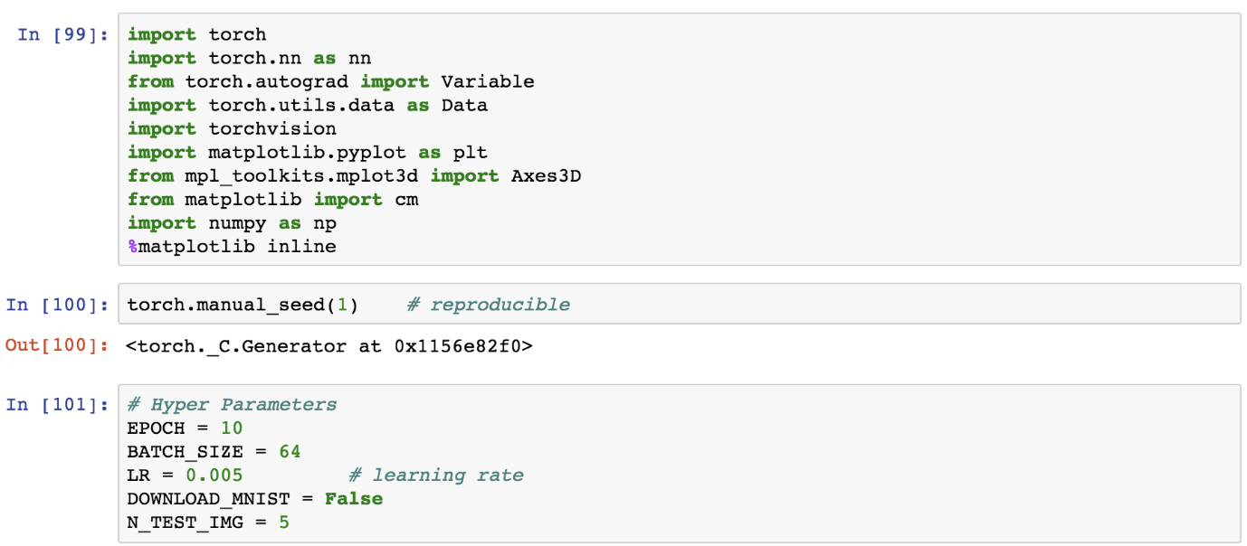

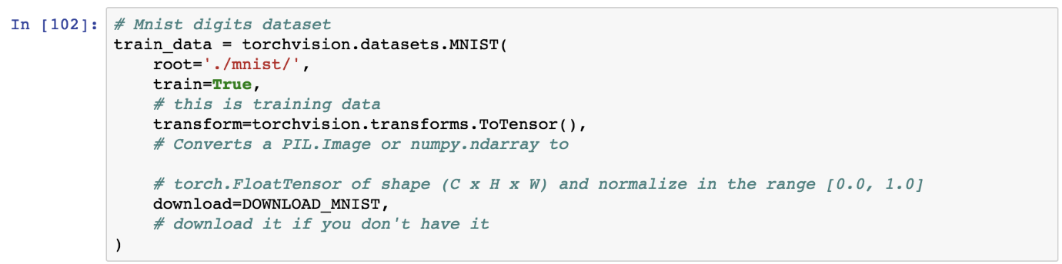

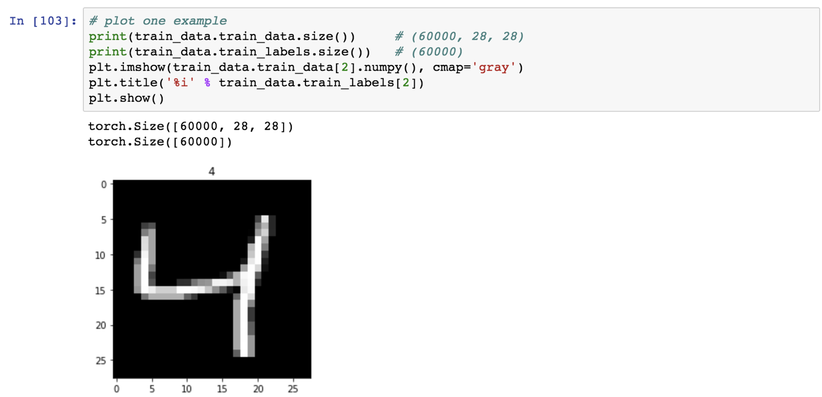

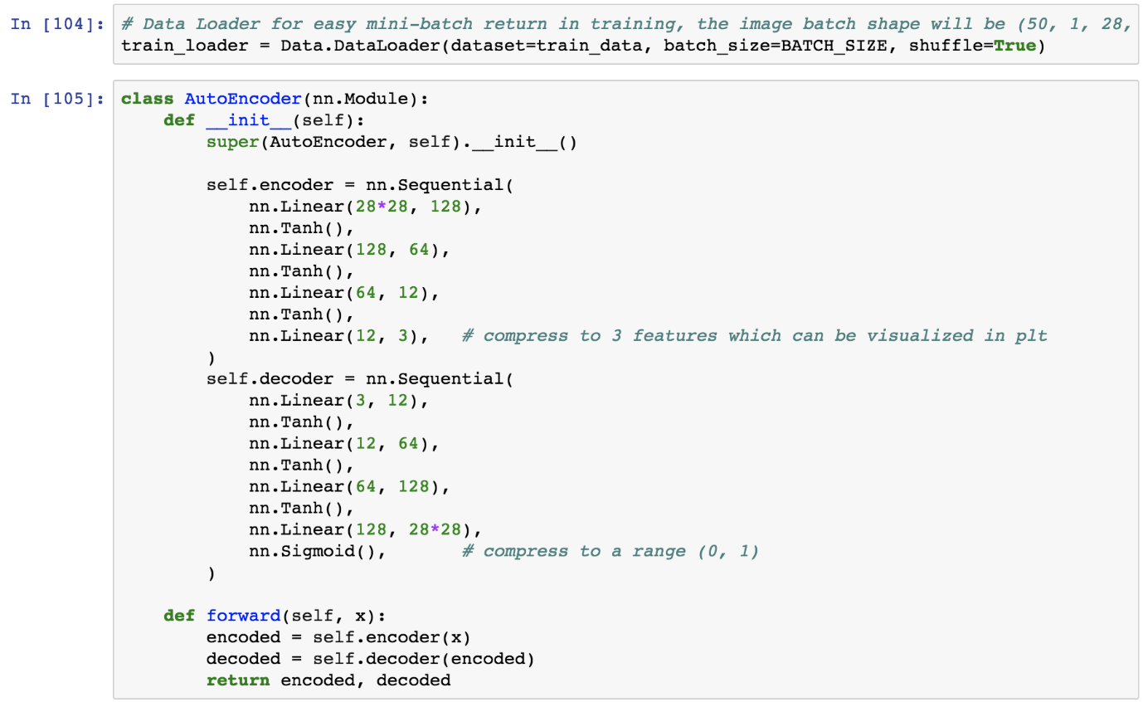

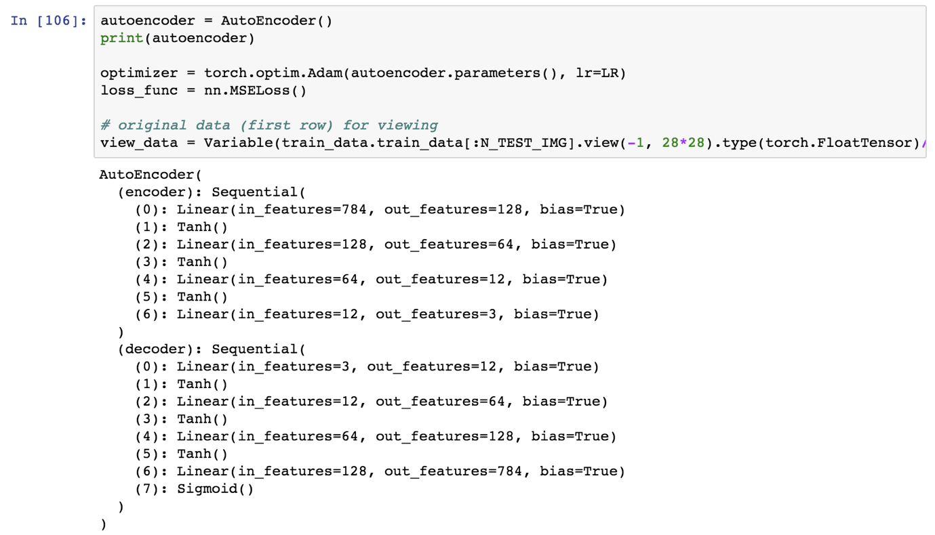

## Problem:

How to set up iterations to fine tune the results.

## Solution:

There are certain functions which are embedded in PyTorch and there are certain loss functions which the user has to create.

## How It works:

Let’s look at the following example.

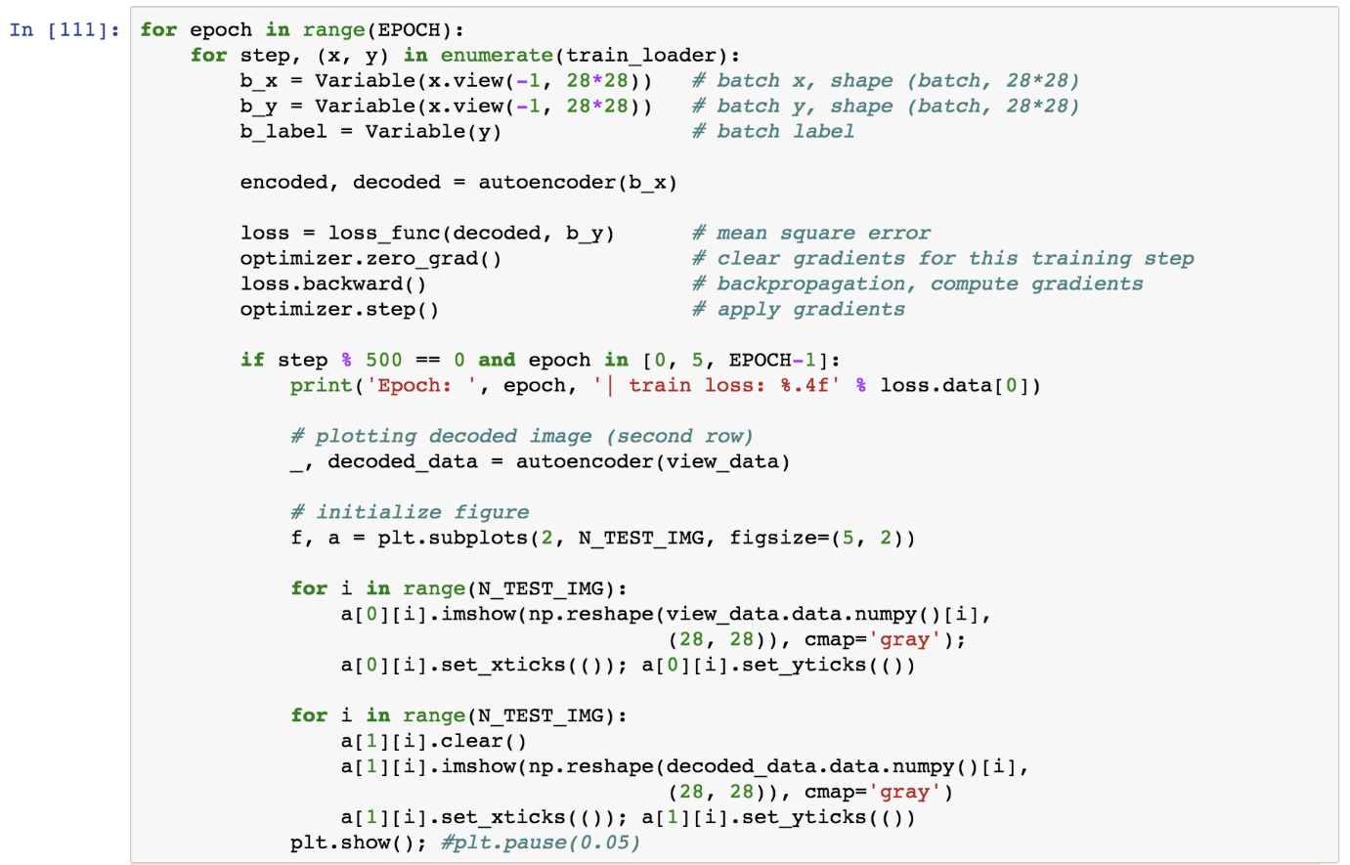

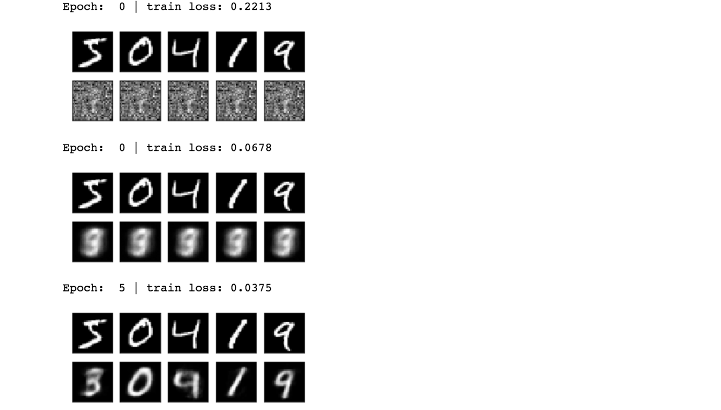

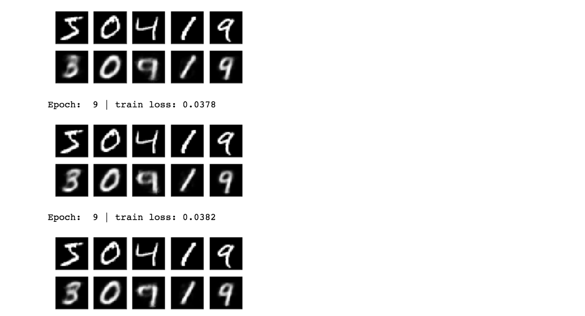

## Problem:

How to visualize the MNIST data in 3D plot.

## Solution:

There are certain functions which are embedded in PyTorch and there are certain loss functions which the user has to create.

## How It works:

Let’s look at the following example.

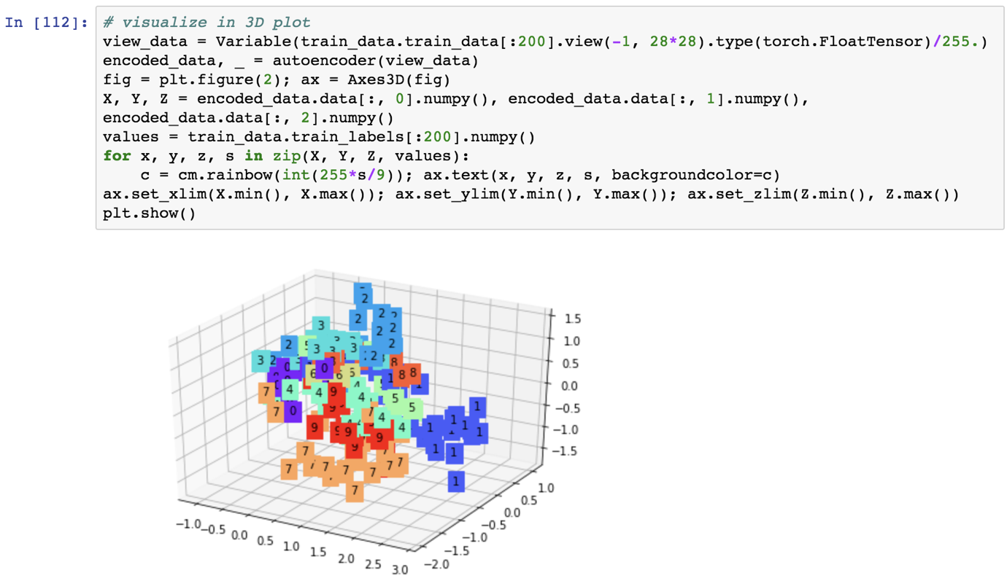

## Problem:

How to set up loss function and optimize the loss function.

## Solution:

There are certain functions which are embedded in PyTorch and there are certain loss functions which the user has to create.

## How It works:

Let’s look at the following example.

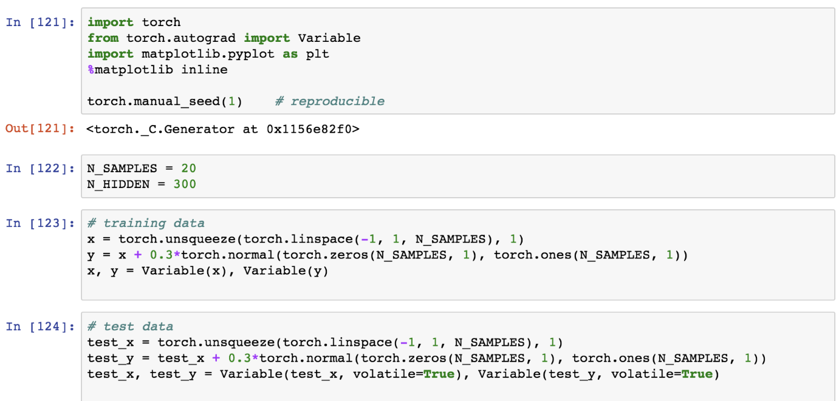

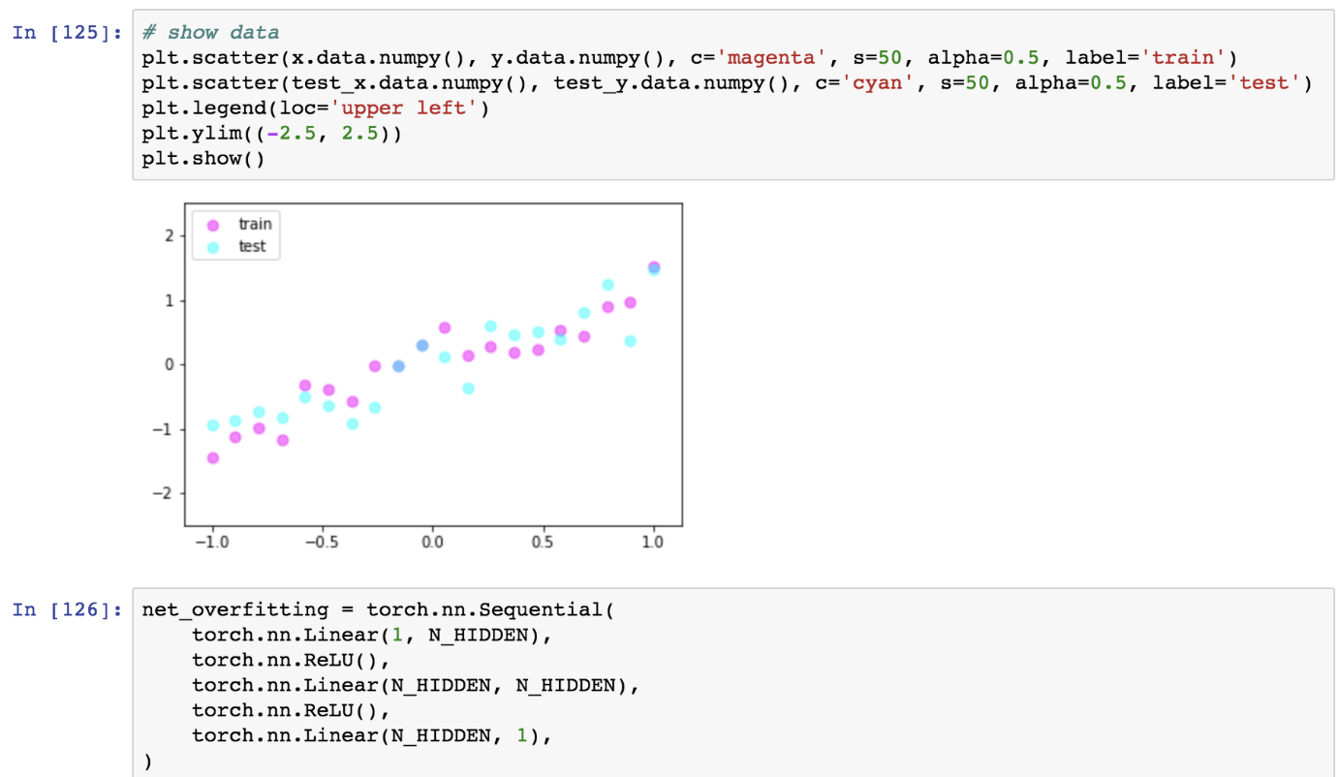

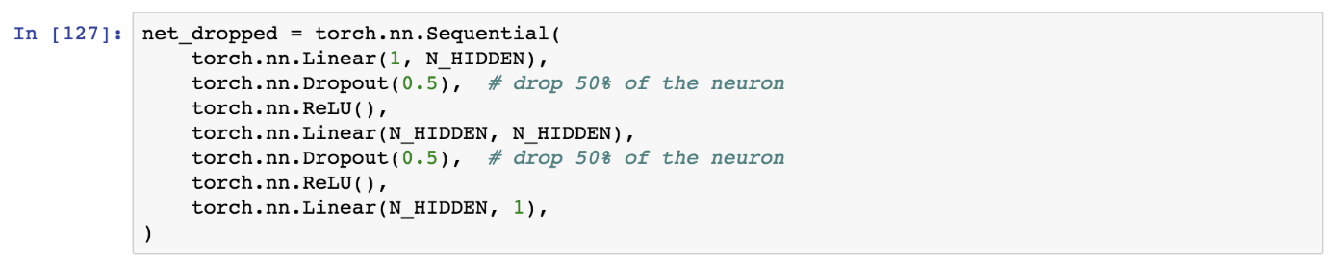

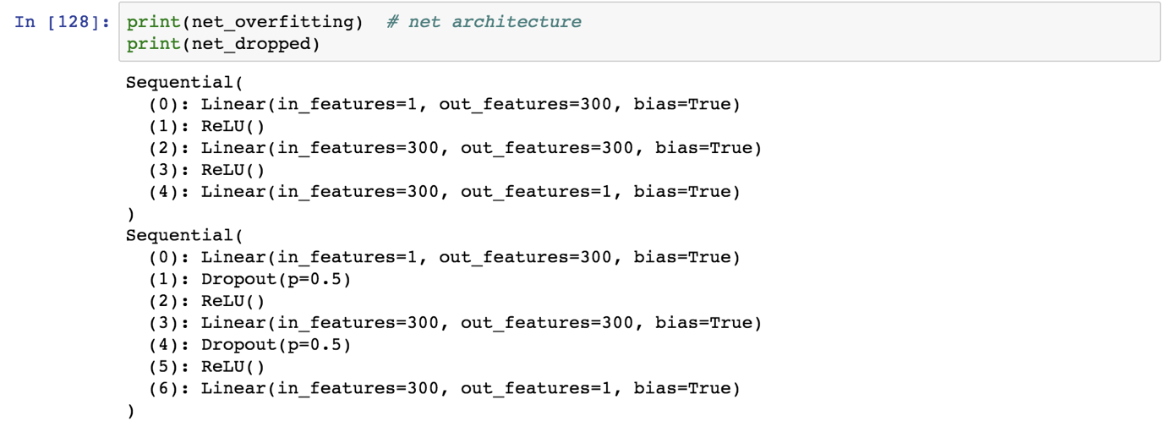



## Problem:

How to set up loss function and optimize the loss function.

## Solution:

There are certain functions which are embedded in PyTorch and there are certain loss functions which the user has to create.

## How It works:

Let’s look at the following example.

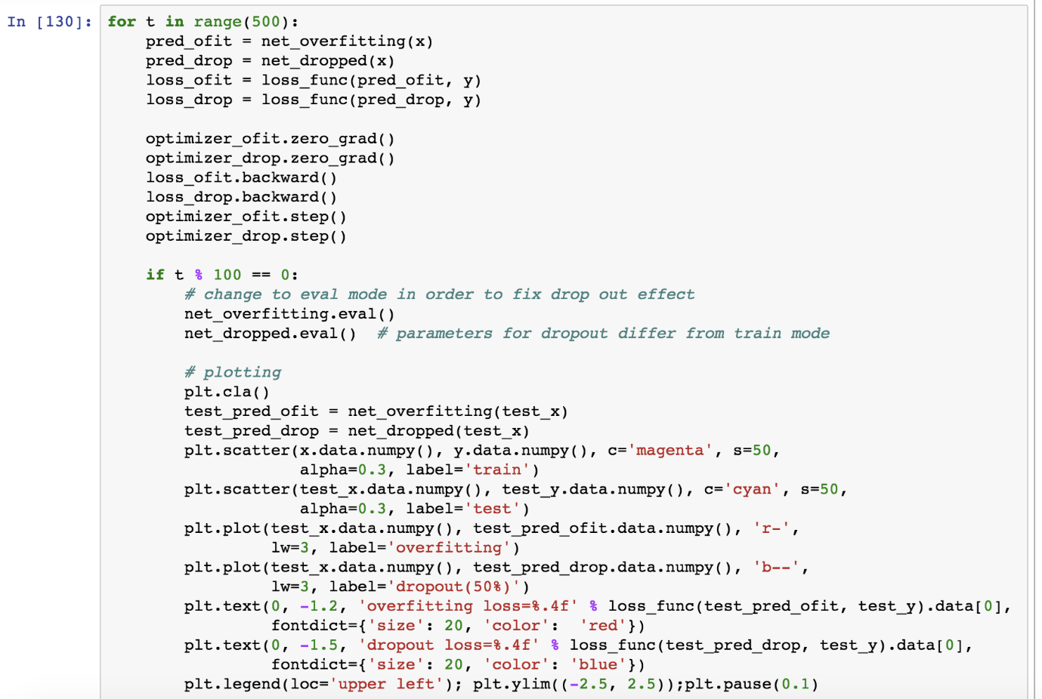



## Problem:

How to set up loss function and optimize the loss function.

## Solution:

There are certain functions which are embedded in PyTorch and there are certain loss functions which the user has to create.

## How It works:

Let’s look at the following example.

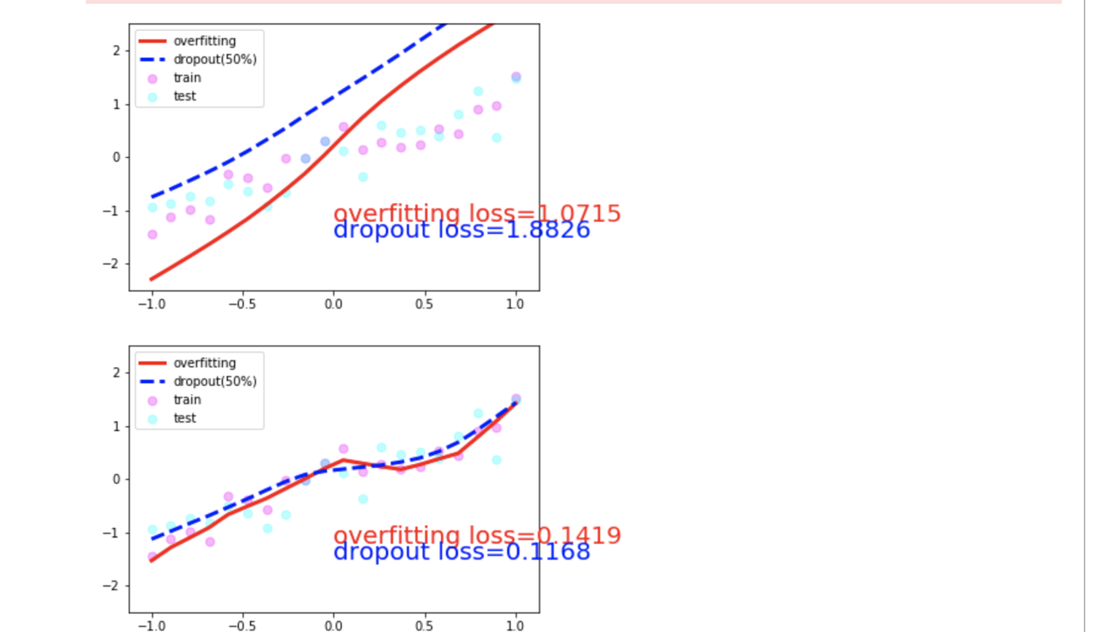

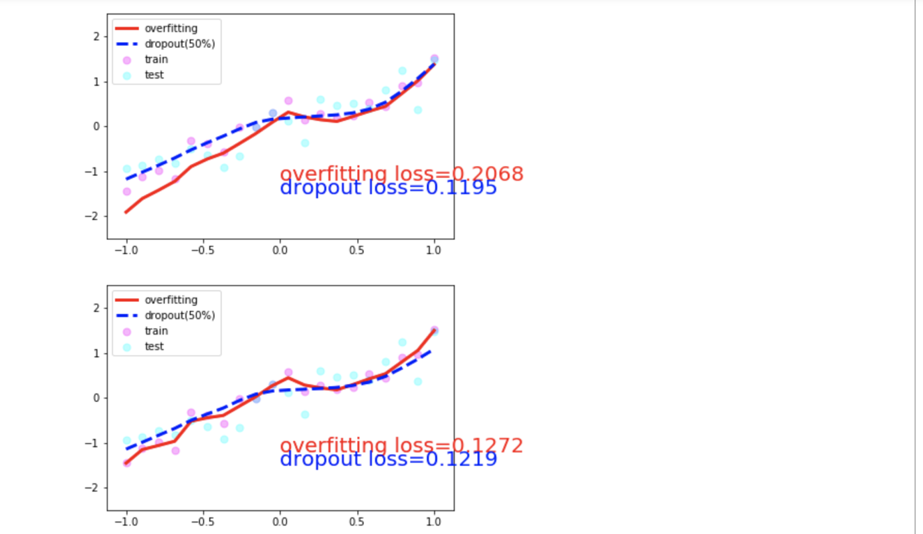

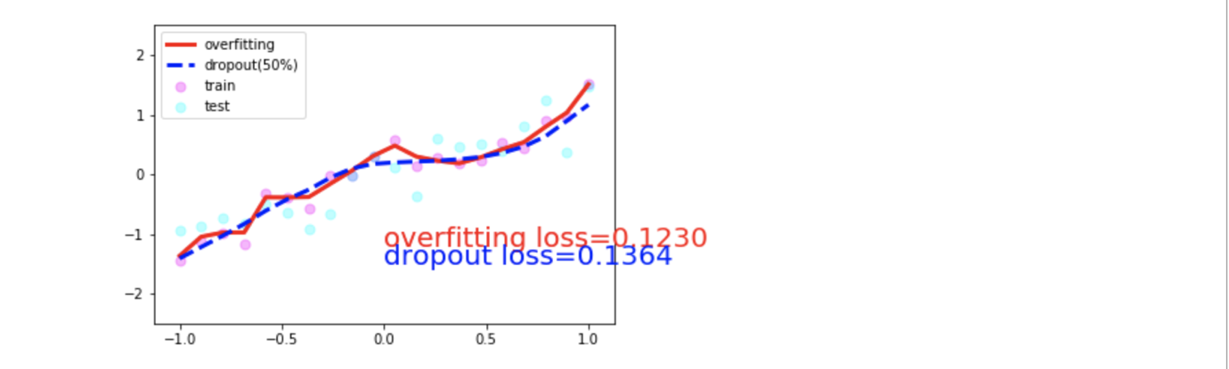

## Problem:

How to set up loss function and optimize the loss function.

## Solution:

There are certain functions which are embedded in PyTorch and there are certain loss functions which the user has to create.

## How It works:

Let’s look at the following example.

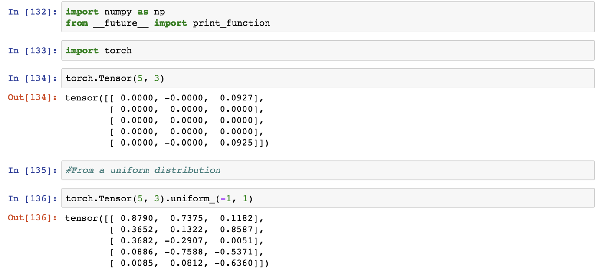

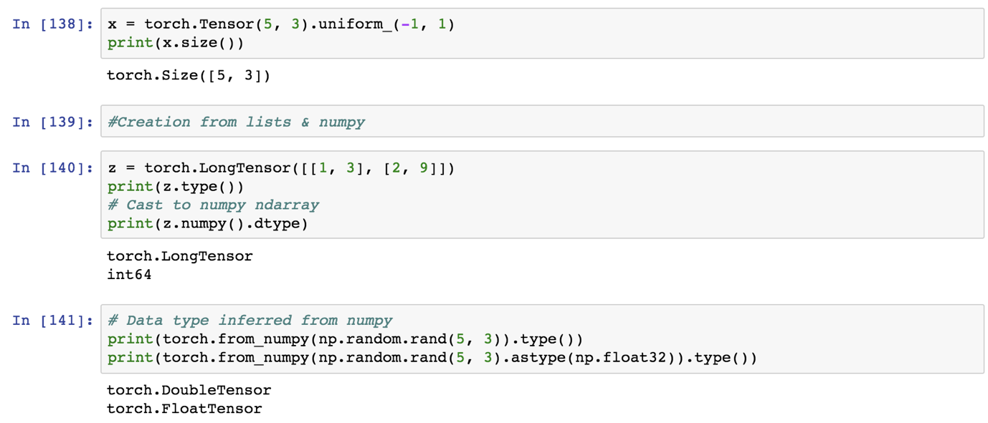

## Problem:

How to set up loss function and optimize the loss function.

## Solution:

There are certain functions which are embedded in PyTorch and there are certain loss functions which the user has to create.

## How It works:

Let’s look at the following example.

## Problem:

How to set up loss function and optimize the loss function.

## Solution:

There are certain functions which are embedded in PyTorch and there are certain loss functions which the user has to create.

## How It works:

Let’s look at the following example.

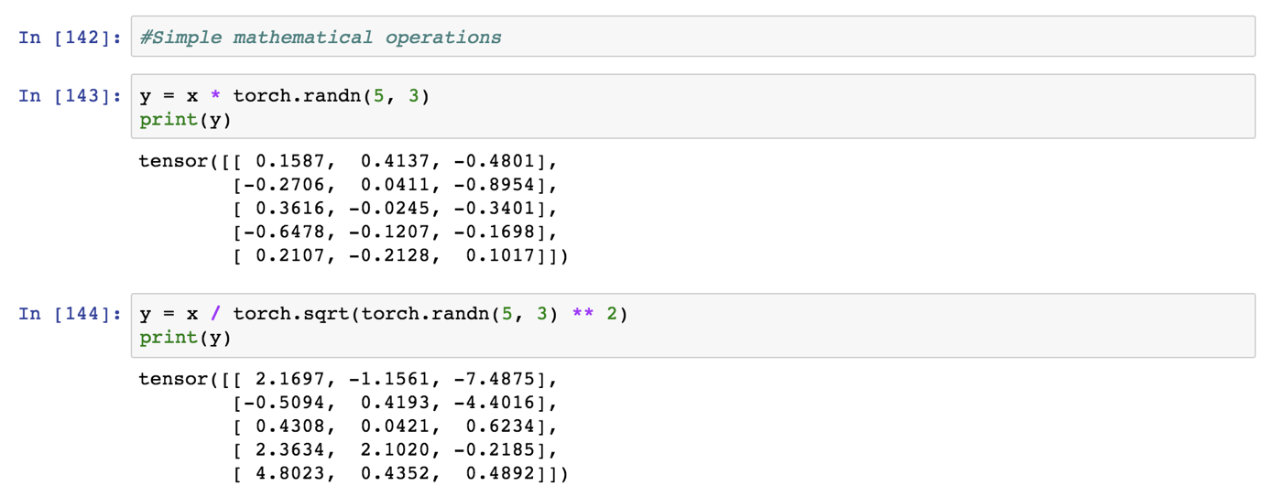

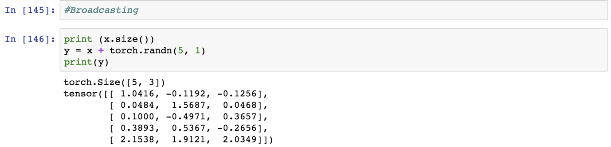

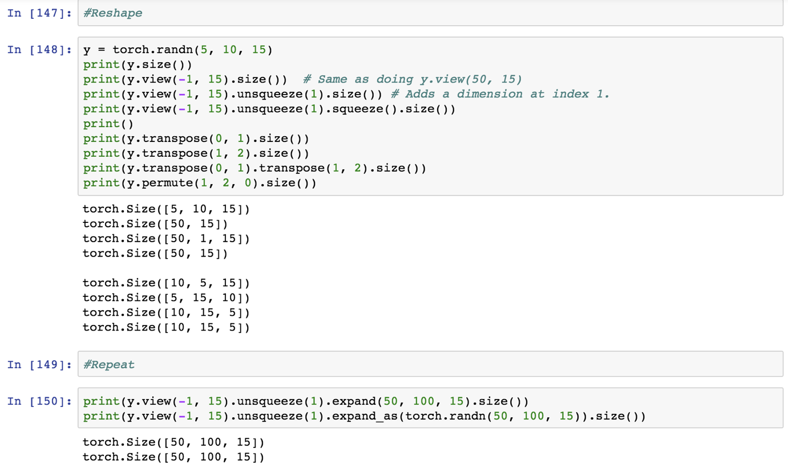

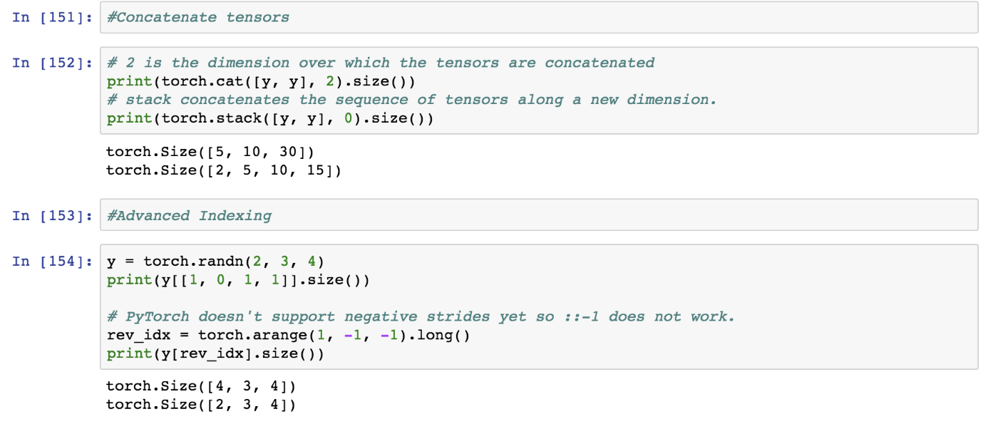

## Problem:

How to set up loss function and optimize the loss function.

## Solution:

There are certain functions which are embedded in PyTorch and there are certain loss functions which the user has to create.

## How It works:

Let’s look at the following example.

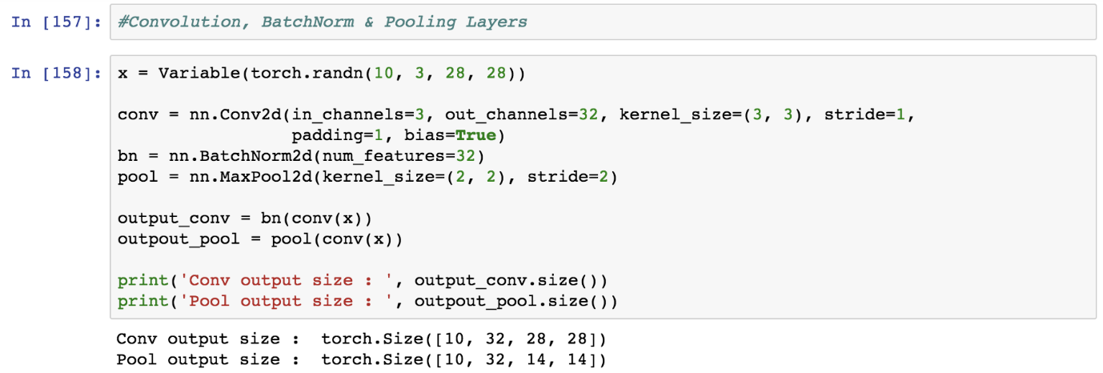

## Problem:

How to set up loss function and optimize the loss function.

## Solution:

There are certain functions which are embedded in PyTorch and there are certain loss functions which the user has to create.

## How It works:

Let’s look at the following example.

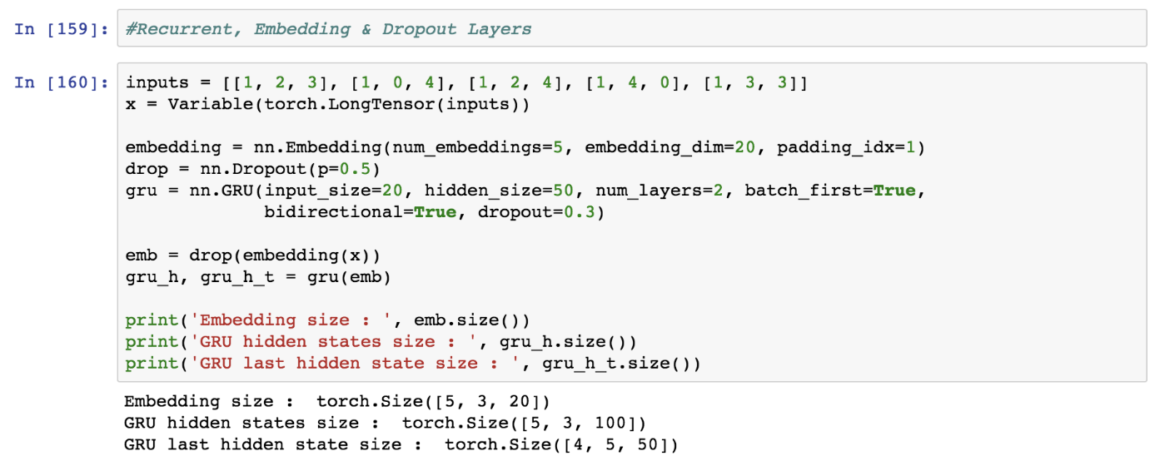

## Problem:

How to set up loss function and optimize the loss function.

## Solution:

There are certain functions which are embedded in PyTorch and there are certain loss functions which the user has to create.

## How It works:

Let’s look at the following example.

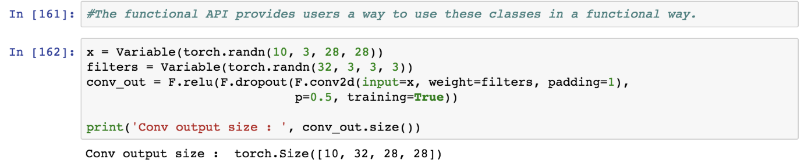

**Conclusion:**